Neighbourhood-scale dispersion of traffic-induced ultrafine particles in central London: WRF large eddy simulations
Jian Zhong¹, Irina Nikolova¹, Xiaoming Cai¹*, A. Rob MacKenzie^{1,2} , Mohammed S. Alam¹, Ruixin Xu¹, Ajit Singh¹and Roy M. Harrison^{1,3}
1. School of Geography, Earth & Environmental Sciences, University of Birmingham, Edgbaston, Birmingham, B15 2TT, UK
2. Birmingham Institute of Forest Research, University of Birmingham, Edgbaston, Birmingham, B15 2TT, UK
3. Department of Environmental Sciences / Center of Excellence in Environmental Studies, King Abdulaziz University, PO Box 80203, Jeddah, 21589, Saudi Arabia
*Corresponding author. Tel.: (0121) 4145533; Fax: (0121) 4145528.
Email address: x.cai@bham.ac.uk (X.-M. Cai).

Abstract: Traffic-generated ultrafine particles (UFPs) in the urban atmosphere have a high proportion of their composition comprised of semi-volatile compounds (SVOCs). The evaporation/condensation processes of these SVOCs can alter UFP number size distributions and play an important role in determining the fate of UFPs in urban areas. The neighbourhood-scale dispersion (over distances < 1 km) and evolution of traffic-generated UFPs for a real-world street network in central London was simulated by using the WRF-LES model (the large eddy simulation mode of the Weather Research and Forecasting modelling system) coupled with multicomponent microphysics. The neighbourhood scale dispersion of UFPs was significantly influenced by the spatial pattern of the real-world street emissions. Model output indicated the shrinkage of the peak diameter from the emitted profile to the downwind profile, due to an evaporation process during neighbourhood-scale dispersion. The dilution process and the aerosol microphysics interact with each other during the neighbourhood dispersion of UFPs, yielding model output that compares well with measurements made at a location downwind of an intense roadside source. The model captured the total SVOC concentrations well, with overestimations for gas concentrations and underestimations for particle concentrations, particularly of the lighter SVOCs. The contribution of the intense source, Marylebone Road (MR) in London, to concentrations at the downwind location (as estimated by a model scenario with emissions from MR only) is comparable with that of the rest of the street network (a scenario without emissions from MR), implying that both are important. An appreciable level of non-linearity is demonstrated for nucleation mode UFPs and medium range carbon SVOCs at the downwind receptor site.
Keywords: Nucleation mode; urban air quality; Multicomponent microphysics; Semi-volatile organic compounds.
Capsule:
The interaction of neighbourhood-scale dispersion and microphysical evolution of UFPs, for a real-world street network in central London, was captured by the WRF-LES-UFP model.

1 Introduction
Ultrafine particles (UFPs) are respirable particles with diameters (Dp) smaller than 100 nm (Pacitto et al., 2019). UFPs can accumulate in lungs (Habre et al., 2018), and penetrate cells/tissue (Geiser et al., 2005) and the blood-brain barrier (Oppenheim et al., 2013), thereby causing adverse impacts on human health (Manigrasso et al., 2017). Although UFPs contribute little to mass concentrations of particulate matter (PM), their toxicity may be greater than larger particles, most likely due to their much larger number concentrations (Sager and Castranova, 2009). The evolution of the UFP number size distribution is therefore of vital importance in order to assess the risk of PM to human health (Alonso-Blanco et al., 2018). In urban areas, UFPs consist predominantly of a large number of different components of semi-volatile compounds (SVOCs) (e.g. Solazzo et al., 2008; Baik et al., 2007; Kwak and Baik, 2014). The evaporation/condensation processes of these SVOCs can alter UFP number size distributions (Zhong et al., 2018; Dall'Osto et al., 2011; Jacobson and Seinfeld, 2004) and thus play an important role in determining the fate of UFPs (Harrison et al., 2018; Harrison et al., 2019; Jacobson et al., 2005; Biswas et al., 2007; Karl et al., 2016; Karnezi et al., 2014).
UFPs related to road vehicles have become an environmental concern and have gained significant attention in recent years. Emissions of UFPs from vehicles in urban areas are often mixed within a street canyon before being diluted into the wider overlying atmosphere. Nikolova et al. (2016) investigated the evolution of vehicle-related UFPs inside a typical street canyon and its dilution from rooftop to a surrounding park, by coupling multicomponent microphysics with the CiTTy-Street box model (Pugh et al., 2012). The model output captured the evaporation of UFPs during street canyon processes and neighbourhood dilution processes. Their sensitivity tests suggested that the coagulation and deposition processes had minor effects on UFP number concentrations compared with the evaporation process. Nikolova et al. (2016) suggested that the exclusion of coagulation and deposition processes may decrease the total particle number by 4.7%–8.2% at the street canyon environment. Subsequently, Zhong et al. (2018) further used their UFP box model to investigate how particle composition influences the evolution of UFPs over typical timescales (~100s) during the neighbourhood scale dispersion (100-1000 m). As discussed further below with respect to our own simulations, some SVOC components have an evaporative timescale similar to the dilution timescale and play a dominant role in the shrinkage of the nucleation-mode peak diameter. Zhong et al. (2018) implemented this scheme of UFP multicomponent microphysics into a two-box model for street canyon compartments with reduced mixing between the in-canyon boxes. The UFP number concentrations were under-estimated by a traditional one box model for street canyon compartments. The ventilation of vehicle-related UFPs between the canyon and overlying atmosphere can be simulated by the street canyon UFP-box model (Nikolova et al., 2016; Zhong et al., 2018). Jacobson and Seinfeld (2004) simulated the downwind evolution of soot particle from point and line emissions using the 3-dimentional Global-Through-Urban Scale Model (GATOR-GCMM) (Jacobson, 2001), suggesting a particle number concentration reduction during the downwind atmospheric mixing process. Jacobson et al. (2005) further investigated the relative effect of coagulation and evaporation processes on particle number size distributions during the downwind evolution from a roadway using the GATOR-GCMM model (Jacobson, 2001). Their study suggested that the coagulation process had a very minor impact for particles larger than 15 nm and may influence very smaller particles less than 10-15 nm (there was a peak for this size range in their study). Kurppa et al. (2019) also found a very minor effect of coagulation process when foucsing on the street canyon analysis at very high spatial and temporal resolutions using the PALM-4U model.
The WRF-CHEM regional model included some aerosol schemes, such as GOCART (without aerosol size) (Chin et al., 2000), MOSAIC (with a few bins covering all sizes up to 10 µm) (Zaveri et al., 2008) and MADE/SORGAM (with three aerosol modes) (Ackermann et al., 1998). To extend the WRF’s capability for UFP simulation at the smaller temporal and spatial scales, Zhong et al. (2019) implemented a UFP microphysics scheme into the WRF-LES (Skamarock and Klemp, 2008) modelling framework (Weather Research and Forecasting, WRF; Large Eddy Simulation, LES), and focused on the linearity of the model output against variations in the background and the emissions of an idealised simple one-line emission source. Their sensitivity study suggested that due to the effect of condensation/evaporation, the linearity is less pronounced for the number concentration of smaller particles (UFP diameter less than 100 nm) and concentrations of medium range organic compounds, which the non-time-dependent Gaussian approach fails to capture. For other passive-like quantities (e.g. concentrations for larger particles and higher range organic compounds), the dispersion can be close to Gaussian.
During atmospheric transport, UFPs undergo aerosol microphysical processes which will, in general, alter particle sizes. As the gases and particles emitted from vehicles are diluted into the atmosphere, the atmospheric partial pressure of vapours may be reduced below the vapour pressure of the vapours in equilibrium with the particle surface. This leads to progressive vaporisation of SVOCs from the particles, causing the particles to shrink. This shrinking phenomenon was observed in field measurements in London (Dall'Osto et al., 2011; Harrison et al., 2018; Harrison et al., 2019) when traffic emitted nanoparticles are advected from the heavily polluted Marylebone Road (street canyon) across the neighbourhood to the adjacent urban park (Regent’s University, RU). The evaporative shrinkage is evident mainly in the nucleation mode, i.e. the mode at aerodynamic diameter less than 30 nm (Zhang et al., 2016). These observations support the hypothesis that particles in the nucleation mode are predominantly composed of SVOC, some of which may evaporate on a timescale of a few hundred seconds.
This study aims to simulate the dispersion and evolution of UFPs at a neighbourhood-scale in central London (specifically covering Marylebone Road and Regent’s University). Simulation of urban flows at the neighbourhood scale inevitably involves trade-offs at current computational capacity. Most often, detail of domain size and the detail of surface structure is traded-off against detail of time-dependent turbulence structure that has a dominant impact on dispersion at the neighbourhood scale. WRF is a very popular community model with a powerful capability of simulating realistic meteorological conditions. With an available LES mode, WRF-LES is able to resolve energy-containing turbulent eddies in the whole atmospheric boundary layer, yielding better captured turbulent dispersion processes than other approaches, e.g. Reynolds-average Navier-Stokes models (RANS with mean flow information only) (e.g. Baik et al., 2007; Kwak and Baik, 2014) and Gaussian models (not time-dependent with simplified representation) (e.g. McHugh et al., 1997; Munir and Habeebullah, 2018). RANS approaches sacrifice dynamical turbulent structure and intermittency, for surface detail. LES approaches sacrifice surface structure or domain size in order to focus on turbulence structures above roof level at the neighbourhood scale. The implementation of the UFP module into WRF-LES (Zhong et al. (2019)) could provide the potential of simulating UFPs in more realistic situations and thus benefit the research community. This new modelling system can be readily applied to other cities with various traffic patterns and meteorological conditions. In this study, real-world gridded emissions are implemented in this neighbourhood-scale simulation to represent a real-world street network, and to reveal the behavior of neighbourhood-scale UFP dispersion. The contribution of the intense source, Marylebone Road (MR) (as estimated by a model scenario with emissions from MR only), to concentrations at a downwind location is compared with that of the rest of the street network (a scenario without emissions from MR).

2 Methodology

2.1 Field campaign in London
The measurements of aerosol properties in London were a part of the FASTER project (Fundamental Studies of the Sources, Properties and Environmental Behaviour of Exhaust Nanoparticles from Road Vehicles) (Harrison et al., 2018) funded by the European Research Council. Sampling was conducted during the winter season in January and February 2017 at several urban sites (e.g. Marylebone Road (MR), Westminster University, Regent’s University (RU), BT Tower, and North Kensington) located close to each other in London. Marylebone Road can be classified as a heavily trafficked (~80,000 vehicles per day) street canyon location (Crilley et al., 2017), while Westminster University is a rooftop site overlooking the ground-level site at Marylebone Road. Regent’s University (a sonic anemometer was installed in this site to inform the meteorological conditions) is a site in a major park frequently downwind of Marylebone Road and 380 m away from the heavy traffic source on MR. The BT Tower is a nearby site with air pollution measurement inlets at an elevation of 160 m above ground. North Kensington is a typical urban background less influenced by local traffic and located 4 km from the Marylebone Road site.
Scanning Mobility Particle Sizers (SMPSs, See Harrison et al. (2019) for more details were used to measure particle size spectra. Modes were fitted to the measured 15 min data using peak fitting software “Fityk” (version 1.3.1, available from https://fityk.nieto.pl/, Wojdyr (2010)). Fityk primarily offers various nonlinear fitting methods, but also provides an option to add your own function types. In the analysis, the lognormal “AerosolPeak” function (Harrison et al., 2019) was used to separate size distributions into lognormal modes by peak fitting. 24h duration samples of SVOCs were collected by an in-house auto sampler (Xu et al., 2019). The air was drawn through a polypropylene backed PTFE filter to collect the particulate phase, and then through a stainless steel adsorption tube to collect the gas phase. Samples were analysed using thermal desorption coupled to two-dimensional gas chromatography time-of-flight mass spectrometry (TD-GC×GC-ToF-MS) (Alam et al., 2016). Individual n-alkanes were identified based on their mass spectra and their retention behaviour. Alkanes and other hydrocarbons were grouped into isomer sets based on their carbon number, providing more than 75% mass or ion-count closure typically (Alam et al., 2018). In the modelling study below, all SVOC is partitioned into n-alkane surrogates of the appropriate volatility (Zhong et al., 2018).

2.2 Numerical simulation

2.2.1 WRF-LES-UFP model
The WRF-LES-UFP model framework developed in Zhong et al. (2019) was used in this study. The filtered transport and dispersion equations for tracers (both gas and particle concentrations) can be coupled with the WRF-LES model (See Zhong et al. (2019) for more details), i.e.
$\frac{∂\tilde{c}}{∂t}+\frac{∂}{∂x_{j}}\left(\tilde{c}{\tilde{u}}_{j}\right)=\frac{∂}{∂x_{j}}\left(K_{c}\frac{∂\tilde{c}}{∂x_{j}}\right)+E+∆\tilde{c}$ (1)
where $\tilde{c}$ is the resolved concentration for a tracer; $K_{c}$ represents the SGS eddy diffusivity; $E$ and $\tilde{c}$ denotes source terms due to emissions and microphysics of UFPs. The source term ($\tilde{c}$) for each tracer in Equation 1 can be obtained from the UFP multicomponent microphysics module (Nikolova et al., 2016; Zhong et al., 2018). There are 18 representative components in the UFP model, including 1 non-volatile core and 17 surrogate SVOCs components (i.e. n-alkanes C₁₆H₃₄-C₃₂H₆₆ labelled as ‘C16’ – ‘C32’). The number of equally-sized bins on a logarithmic scale (covering geometric mean diameters of 6.7 nm-501.4 nm) for the UFPs is 15. For each size bin, a particle consists of 18 components represented by 18 tracers in the model with each size bin free to take a different set of fractions from other size bins. Thus the total number of tracers for the particles of interest is 270 (=18×15). The particle number concentration for each size bin is calculated by the ratio of the total mass concentration to the representative one-particle mass at the mid-point of the sectional size bin. The allocation of particle and vapour mass to specific surrogate n-alkanes is based upon integration of the chromatogram of engine exhaust (source) and atmospheric samples within volatility bands corresponding to each n-alkane (see Table S1 in supplement for volatility bin) (Xu et al., 2019). The total number of tracers in the gas phase is 17, corresponding to each of the surrogate SVOC components in the particle phase.
The condensation and evaporation of SVOCs play a dominant role in the evolution of UFPs at the neighbourhood scale (Zhong et al., 2018; Harrison et al., 2016), and so these are the processes which are included in the UFP multicomponent microphysics module of the WRF-LES model. Neighbourhood-scale dispersion (100-1000 m) has a short timescale in the order of a few minutes. Coagulation and deposition processes are omitted due to their relatively longer time scale compared with condensation/evaporation processes (Zhong et al., 2018). Coagulation process has a very minor impact for particles larger than 15 nm (See Section S1 in supplement for coagulation time scale estimation), consistent with Jacobson et al. (2005).The mass transfer rate between each SVOC component (q) of a typical UFP at a size bin (jb) and that in the gas phase is described as (Jacobson, 2005):
$\frac{d{\tilde{m}}_{q,jb}}{dt}=a_{FS}^{jb}\frac{2πd_{jb}{M_{q}D}_{q}}{RT}(e_{q}^{∞}-X_{q,jb}a_{K}^{q,jb}e_{q}^{vap})$ (2)
where $a_{FS}^{}$ represents the Fuchs-Sutugin correction factor; d (m) is the diameter of a UFP in size bin jb; M (g mol⁻¹) and D (m² s⁻¹) are the molar mass and the vapour diffusivity, respectively; R (J mol⁻¹ K⁻¹) and T (K) are the universal gas constant and the absolute temperature, respectively; $X$ denotes the mole fraction; $a_{K}^{}$ accounts for the Kelvin effect; $e_{q}^{∞}$ (Pa) is the ambient partial pressure which can be calculated based on gas phase concentration using the ideal gas law; $e_{q}^{vap}$ (Pa) represents the saturation vapour pressure (see Table S2 in supplement) we obtained from the UManSysProp online tool (Topping et al., 2016) using inputs from Compernolle et al. (2011) as these best matched an experimental determination of vapour pressures (Alam et al., 2019). Then the source term for each SVOC component (q) in the gas phase is:
$∆{\tilde{c}}_{q}=-\sum_{jb}{\frac{{\tilde{N}}_{jb}d{\tilde{m}}_{q,jb}}{dt}}$ (3)
where ${\tilde{N}}_{jb}$ is the resolved UFP number concentration in the size bin (jb). After the condensation/evaporation process, the particle size would change and a redistribution scheme for both the number and mass concentrations in the particle phase to the sectional size bin can be adopted as that in Zhong et al. (2018) to enable the advection and diffusion of UFP in the three-dimensional Euler grid system (Debry et al., 2007).

2.2.2 Model setup
The size of the computational domain was 2540 m×2540 m×1000 m (L_{x}×L_{y}×L_{z}) with horizontal grid resolutions of 20 m × 20 m (Δx×Δy) and 79 vertical stretched grids of Δz (from ~0.68 m up to ~60 m), covering Marylebone Road and its adjacent urban park (Regent’s University) in central London. Building geometries are typically at the length scale similar to the grid resolution (20 m) and are not able to be resolved explicitly in this study. There is a trade-off in modelling the neighbourhood scale, between the representation of the processes inside street canyons and of those above roof level. We choose to put more focus on the latter for the following reasons: (1) details of the UFP emission profile were derived from the measurement inside the canyon, representing the well mixed air parcels emitted into the space above the roof level; (2) we aim to focus on the processes of turbulent dispersion and UFP aerosol dynamics above the roof level; (3) to represent UFP aerosol dynamics in WRF, we coded 270 extra 3D variables (=15 size bins $×$ 18 species; see details in “Supporting Information”), and this requires considerable extra computation. Resolving buildings, with e.g. $Δ\sim$2 m, would need 127.5 million grid points to cover the neighbourhood scale domain, making the modelling impracticable.
It is assumed that the urban canopy is homogeneous without a significant variance in height and roughness at the grid resolution. The surface momentum flux (in the form of a drag coefficient of 0.048) and heat flux (13 W m⁻²) were specified at the bottom of the computational domain as the lower boundary condition of momentum and heat, respectively, based on the sonic anemometer measurements for the 180º±25º wind sector of the campaign period (Harrison et al., 2019), i.e. ~50 daytime hours from 28 January to 15 February 2017. The initial vertical profile of potential temperature was specified based on the measured boundary layer height of ~ 500 m averaged over the same period under the 180º±25º wind sector by ceilometer at the North Kensington urban background site (http://www.met.reading.ac.uk/micromet/LUMA/new/index.php), i.e. constant 282.15 K up to 475 m with $∂T/∂z$ of 0.05 K m⁻¹ for 475 m-625 m and of 0.003 K m⁻¹ for 625 m-1000m. To prevent gravity wave reflection at the domain top, a damping layer of 300 m was adopted. The geostrophic wind field of U_{g}=5 m s⁻¹ and V_{g}=10 m s⁻¹ was specified so that the surface wind can be roughly from the south. The lateral boundary conditions were periodic for the turbulent flow, and fixed inlet together with open outlet for both gas and particle concentrations. The turbulent flow was solved in a time step of 0.2 s and the multicomponent microphysics of UFPs had adaptive time steps for a wide range of timescales for condensation/evaporation processes. The turbulent flow had a spin-up period of 8 hours before the UFPs module was active for the further 30 min. The last 10 min output of every 3 s was stored for post-processing.
A real-world street network with gridded traffic activity relative to Marylebone Road (Figure 1) in central London (The traffic activity map is based on the London Atmospheric Emissions Inventory (LAEI) 2013, https://data.london.gov.uk/dataset/london-atmospheric-emissions-inventory-2013) was implemented at the bottom of the domain. The average traffic activity of 3740 vehicle hour⁻¹ for the 180º±25º wind sector of the campaign period (Harrison et al., 2018) is used in the calculation of the total emissions for Marylebone Road. The emissions on other road network for the same period were scaled to Marylebone Road based on the relative traffic activity from LAEI 2013 annual traffic map (Figure 1). The total UFP number concentration emission factor for Marylebone Road (7.93×10¹³ particles vehicle⁻¹ km⁻¹) was updated for the 2017 London campaign period based on that in Jones and Harrison (2006) with a reduction factor due to the advancing technology for vehicles, derived from measured UFP concentrations. In order to generate the size-dependent UFP emission rates, the total UFPs emission rates (derived from the traffic activity and the total UFP number concentration emission factor) were then scaled by the mode fitting profile of the traffic increment, i.e. the difference between Marylebone Road (roadside) and North Kensington (urban background) for the 180º±25º wind sector. The non-volatile core for a size bin in emitted UFPs had a mass fraction of 1% for nucleation mode followed by an increase up to 99% for the accumulation mode. The remaining mass fractions for a size bin were then occupied by volatile core (SVOCs), which were scaled by the SVOCs emission factors in the particle phase (estimated based on the difference between the south wind and north wind measurements at Marylebone Road (Xu et al., 2019), as there were no SVOCs measurements at the urban background site-North Kensington). The SVOC emission factors were 681 μg veh⁻¹ km⁻¹ for the total grouped gas concentrations and 1714 μg veh⁻¹ km⁻¹ for the total grouped particle concentrations (see Table S3 in supplement). The incoming background UFP number-size distribution at the inlet for the computational domain was based on mode-fitting of SMPS measurements at the nearby elevated BT Tower (about 160 m above ground). The BT tower represents an overlying neighbourhood background, only slightly influenced by local street emissions. The inlet SVOCs were inferred based on the measurements from Regent’s University (scaled by the ratio of the common black carbon measurements between BT tower and Regent’s University) (see Table S4 in supplement). The incoming background UFPs at the inlet for a size bin had a non-volatile core mass fraction of 1 % for the nucleation mode with an increase up to 99% for the accumulation mode and the SVOC mass fractions were then scaled by the inferred inlet SVOCs of UFPs (based on the measurements from Regent’s University but with a correction based on the ratio of the common black carbon measurements between BT tower and Regent’s University).

3 Results and discussion

3.1 Full street network emission scenario

3.1.1 Total UFP number concentration
Figure 2(a) illustrates a horizontal slice of the total UFP number concentration (UFPNC) ($C_{m}$ representing a temporal average over the final 10 min output from the model for each location in the domain) at the bottom level. There is clear evidence of the direct influence of the urban street network over central London (Figure 1) on the neighbourhood-scale dispersion of the total UFPNC under a southerly wind. Vehicle-induced UFPs released from the urban street network are gradually transported towards the north neighbourhood with a decrease in the total UFPNC before passing through the downwind adjacent streets. The spatial pattern of the total UFPNC is greatly influenced by the relative traffic activity as indicated by Figure 1, i.e. a higher traffic activity would normally have a higher total UFPNC under a similar wind condition. Figure 2(b) is a vertical slice of total UFPNC (temporally averaged over the final 10 min output from the model) along the South-North direction (indicated in Figure 2a), which reflects the cross-sectional transportation of total UFPNC at the neighbourhood scale. During the downwind neighbourhood dispersion, plumes emitted from local streets expand vertically. Figure 2(c) shows a vertical slice of the concentration fluctuation intensity (induced by resolved unsteady turbulent eddies by the LES model) normalised by the mean concentration for total UFPNC, i.e., $C^{'}/C_{m}=\sqrt{{\left(C-C_{m}\right)}^{2}}/C_{m}$ , with $C_{m}$ representing a temporal average for each location in the domain. There are maxima of the concentration fluctuation intensity for the locally emitted plumes, with a gradual decrease along their downwind side until a subsequent emission is encountered. Figure 2(d) illustrates the total UFPNC and its variability, ($C_{m}{±C}^{'}$), along a South-North line (indicated in Figure 2a) at the bottom level. The peak values (local maxima) of the total UFPNC indicate the influence of vehicle-induced UFPs from the streets. The magnitudes of these maxima indicate relative traffic activities. There is a rapid decrease in the total UFPNC downwind close to the street emissions and a gradual decrease at further downwind distances during the neighbourhood dispersion. In comparison of measurements at Regent’s University (RU), the model produces a slight underestimation in number concentration of about 9.5%. This may be attributed to the uncertainty of the inputs relating to the UFP emissions/background, the meteorological conditions and complex building geometry in the real world.

3.1.2 UFP number-size distribution
Figure 3 illustrates the UFP number-size distribution (NSD) temporally averaged over the final 10 min output from the model for the Marylebone Road north-side (downwind side) rooftop (MR Rooftop) and a downwind location in Regent’s University (RU). The shaded areas indicate their associated fluctuation intensity. There is evidence of the direct impact of the emitted profile of UFPs on the UFPNC density of the MR Rooftop cell, indicated by their same peaks (both at bin 5 of [19.8 nm, 26.9 nm]). There is a decrease in the mean number concentration and its fluctuation for all size bins from the modelled MR rooftop to the modelled downwind RU, indicating the dominating dilution effect at the neighbourhood scale dispersion captured by the model. The clear shrinkage of the peak diameter from bin 5 [19.8 nm, 26.9 nm], for the modelled MR rooftop, to bin 4 [14.6 nm, 19.8 nm] for the modelled downwind RU reflects the effect of evaporation of SVOCs (discussed further below with reference to Figure 4) during neighbourhood-scale dispersion. The evolution of the UFPs NSD at the neighbourhood scale is influenced by the interaction between the mixing and the evaporation processes for smaller particles (<100 nm) and dominated by the mixing process for larger particles (>100 nm) (See Section S2 in supplement for dilution ratio analysis). This model captured the evaporation behaviour, observed in the measurements from emissions (MR_obs in Figure 3) to its downwind locations (RU_obs in Figure 3). Compared with the measured and modelled UFP NSD at the downwind location in RU, this current model underestimates the number concentrations for UFPs with geometric mean diameters smaller than 50 nm, but with a slight overestimation for UFPs with geometry mean diameters larger than 50 nm. The model captured the same peak diameter in RU as that of the measurements (Harrison et al., 2019),while the magnitude of number concentration for the peak diameter in the model is lower than that in the measurement. As the real-world conditions are very complex, it is challenging for the current model to match the exact number concentration. It is promising that the similar evaporative behaviour is well captured by the model.

3.1.3 SVOCs concentrations
Figure 4(a-c) shows SVOC concentrations in the gas and particle phases at the MR rooftop and the downwind Regent’s University. For the MR rooftop, there are high levels of modelled SVOC concentrations due to the direct effect of emissions from Marylebone Road. Compared with the measurements of SVOCs for the downwind RU, the model generally captured the total SVOCs concentration (the sum of gas concentration and particle concentrations) for most organic compounds (shown as Figure 4a). This suggests that the model performs well for the dispersion of a passive scalar. Figure 4(b-c) shows the portioning between the gas and particle (See Fig. S4 in supplement for an example of size-resolved SVOCs concentrations at RU) concentrations. For the MR rooftop with the very short time scale downwind of the emission source, the SVOC concentrations of lower carbon number (e.g. C16-C20) in the particle phase rapidly approach their background values, indicating very rapid evaporation (with high saturation vapour pressures and low partial pressures, see Table S2 in supplement), which transfers SVOC from the particle phase into the gas phase. Consequently, there are high levels of gas concentration (Figure 4b) and negligible levels of particle concentration (Figure 4c) for lower carbon organic compounds. The evaporation process plays a dominant role over the dilution process for the region near emissions for SVOCs with lower carbon number. For the medium-length carbon organic compounds (C21-C26), the evaporation process and dilution process interact with each other since the timescales for both processes are comparable during the neighbourhood scale dispersion (Zhong et al., 2018). The dilution process reduces the concentrations in both gas and particle phases while evaporation increases gas concentrations at the expense of particle concentrations. It is not surprising that the reduction of modelled gas concentrations for C24-C26 from the MR rooftop to the downwind RU is not significant. This is attributed to the generation of vapour for C24-C26 due to the evaporation process during the neighbourhood dispersion. For the high carbon-number components (C27-C32) with much lower saturation vapour pressures, the time-scale for the evaporation/condensation process is slow indicating the slower conversion between the gas and particle phases of SVOCs. The concentrations of these compounds in the gas and particle phases were almost wholly determined by dilution processes, with very little influence of the evaporation/condensation process. This passive-scalar-like behaviour is similar for the total of SVOCs gas and particle phase concentrations (Figure 4a).
For low- and medium-carbon organic compounds (C16-C26), the model overestimates the gas phase SVOC concentrations and underestimates the particle phase SVOCs concentrations; in other words, the modelled gas-to-particle mass ratios are higher than the observed ones. There is an inconsistency between the measured gas concentrations at RU and the (quasi-)equilibrium gas concentrations calculated from the saturation vapour pressure estimated from the “Laboratory” data (Topping et al., 2016; Compernolle et al., 2011). For example, the measured $C_{gas}$ for a low-carbon organic compounds, e.g. C16, is about 16.2 ng m⁻³ as indicated in Fig. 4(a). However, the extremely high vapour pressure for C16 is $6.4×{10}^{-2}$ Pa causes a very fast evaporation to reach equilibrium, yielding a value of $C_{gas}$ required by the equilibrium: $C_{gas,C16}^{equi}$~5.5×10⁵ ng m⁻³, which is much larger than the observed value of about 16.2 ng m⁻³ shown in Fig. 4 (a). This estimate is based on an equality of the two terms inside the bracket at the right hand side of Equation (2), i.e. $e_{q}^{∞}=X_{q,jb}a_{K}^{q,jb}e_{q}^{vap}$ together with a typical molar fraction of 0.06 and a typical Kelvin coefficient of 1.5. Our recent measurements of SVOC vapour pressures are lower than Compernolle et al. (2011), but within an order of magnitude (Alam et al., 2019), so cannot account for the much lower apparent vapour pressure in the measurements. Kinetic constraints on reaching gas-particle equilibrium may be playing a part but we are unable to test these mechanisms with the model as it stands. This may be attributable to adsorption phenomena which are not included in our description of vapour-particle partitioning.

3.2 Subset scenarios from full street network emission
In order to investigate the contribution solely from Marylebone Road and the contribution solely from other streets, subset scenarios from full street network emissions (Case “Full network”) are configured, i.e. a scenario with emissions from Marylebone Road only (Case “MR only”) and a scenario with emissions only from other streets (Case “Others”). We call the two cases (Case “MR only” and Case “Others”) the “partial-emission cases”, and call Case “Full network” the “full-emission case”. The nonlinear interaction between Case “MR only” and Case “Others” can be also examined by assessing the traffic-induced concentration difference between the sum of these two subset scenarios and the full street network scenario (Case “Full network”). In Zhong et al. (2019), we investigated the linearity of model output against variations in the background and the emissions of a simple linear emissions source. We adopt a similar approach here to study the effects of Marylebone Road itself and the roads surrounding Marylebone Road. For each scenario, the traffic-induced concentration ($\hat{C}$) is defined as the modelled concentration ($C$) with a subtraction of background concentration ($C_{bg}$) (Our investigation of the model output indicates that this subtraction of background is necessary in such comparisons), i.e.
$\hat{C}=C-C_{bg}$ (4)
Figure 5(a-b) illustrated the horizontal slices of the total UFP number concentration (UFPNC) (temporally averaged over the final 10 min output from the model) at the bottom level for Case “MR only” and Case “Others”. For Case “MR only”, the influence of the MR is mainly on its downwind locations under a southerly wind, with a decrease in the effect of the emissions seen in the north neighbourhood. For Case “Others”, the influence of the urban street network on the upwind of MR is similar to that for Case “Full network” in Figure 2(a), while from MR downwind, the dispersion is influenced by the upwind concentration (without a strong contribution from MR emission) and the local streets. Figure 5(c) shows the traffic-induced total UFPNC ($\hat{C}$) along a South-North line at the bottom level for all scenarios. The sum of Case “MR only” and Case “Others” is very close to Case “Full network”, as expected since total UFPNC can be considered effectively a passive scalar. This indicates that the concentration of a passive scalar at a given location can simply assumed to be a sum of contributions from a variety of individual emissions in the modelling practise, which is the assumption used in the ADMS dispersion modelling (Stocker et al., 2012) and similar Gaussian plume approaches. The contribution of Case “MR only” is negligible at upwind locations of MR and is significant at its near downwind locations before being slightly overwhelmed by Case “Others” (due to the presence of other local streets). The concentrations at RU for Case “Others” and for Case “MR only” are comparable to each other; this level of concentration is also similar to that approaching MR for Case “Others”. This observation will be used in the discussion below with respect to the results in Figure 7. An additional note is that the impact of the emissions from the southern section of a road around Regent’s Park, called Outer Circle (classified in “Others”), on the passive scalar’s concentration at the RU site is non-negligible.
Figure 6 shows the traffic-induced UFP NSD (temporally averaged over the final 10 min output from the model) at MR Rooftop and at RU for all scenarios. At MR Rooftop, there are slight variations between the sum of Case “MR only” and Case “Others”, and Case “Full network”. This is due to the direct effect of MR emissions with minor influence due to aerosol microphysics at MR Rooftop. It is also noted that at MR Rooftop, the contribution of Case “MR only” is much larger than that of Case “Others”. At MR Rooftop, Case “MR only” is peaked at bin 5 of [19.8 nm, 26.9 nm] (the same as that for emitted profile of UFPs in Figure 3), while Case “Others” is peaked at bin 4 of [14.6 nm, 19.8 nm] (with a combined influence of the dispersion of upwind street emissions and aerosol microphysics). At RU, the sum of Case “MR only” and Case “Others” is slightly higher for particles less than 15 nm and is slightly lower for particles between 15 nm-100 nm compared with Case “Full network”. This indicates the effect due to evaporation process is mainly for particles below 100 nm, and that the sum of Case “MR only” and Case “Others” slightly overestimates the evaporation compared with Case “Full network”. At RU, the contribution of Case “MR only” is just slightly lower than that of Case “Others”, indicating that the contribution of Case “MR only” to the full case is slightly lower than 50 % and the influence of the rest of the street network cannot be ignored at this downwind location. All scenarios are peaked at bin 4 of [14.6 nm, 19.8 nm] at RU, indicating the effect of evaporation from MR as well as other emissions (peaked at bin 5 of [19.8 nm, 26.9 nm]) during travel towards RU.
An appreciable level of non-linearity is demonstrated by the disparity between the NSD curves of “Full network” and “MR only+Others”. For UFPs of $D_{p}∈[14.6 \text{nm},100 \text{nm}]$, total particle number for “Full network” is higher than that for “MR only+Others”; for the nucleation mode with the smaller $D_{p}$, the opposite happens. Neglecting the quantitative details momentarily, we can see an evident pattern that the NSD of “MR only+Others” (the sum of two partial-emission cases) is shifted to smaller particle sizes than the NSD of “Full network” (the full-emission case). This is interpreted as suppressed evaporation process of the SVOC particles for the full-emission case when all streets are emitting SVOCs (thus leading to higher partial pressures of SVOCs in the atmosphere) in comparison with the summed effect (the curve “MR only+Others” in Fig. 6(b)) for two partial-emission cases, Cases “MR only” and “Others”. It is well known that evaporation will in principle cause a NSD curve to be shifted to the left. Such behaviour is illustrated by two contrasting curves: (i) the curve “MR only+Others” in Fig. 6(b), representing the summed NSD curve of the two partial-emission curves (Cases “MR only” and “Others”), and (ii) the curve “Full network” in Fig. 6(b), representing the NSD for the full-emission case. In a quantitative sense, this non-linear effect is most prominent for the Aitken mode and a linear sum of the NSD values of partial-emissions will underestimate the true NSD values. For the nucleation mode, however, the linear method will overestimate the true NSD values. The least impact for the accumulation mode is explained by the high mass fractions of non-volatile core.
Figure 7 shows traffic-induced SVOCs concentrations in the gas and particle phases (temporally averaged over the final 10 min output from the model) at MR Rooftop and at RU for all scenarios. Figure 7 (a) & (b) show that for both MR rooftop and RU sites, the total of gas and particles SVOCs concentrations matches well between the sum of Case “MR only” and Case “Others”, and Case “Full network”, suggesting that the total (gas+particle) concentrations behave like a passive scalar and that these concentrations induced by full-network emissions can be estimated by summing the mass concentrations induced by multiple subset emissions. At RU, the contribution of Case “MR only” is comparable with that of Case “Others”, indicating both the emissions from MR road and the emissions from other streets are important in determining the concentrations at RU. Figure 7 (c) & (e) show that traffic-induced SVOCs concentrations (both gas and particle) in Case “MR only” are much larger than these in Case “Others” at MR Rooftop, whilst at the RU site, these two curves are very close to each other (Fig. 7 (d) & (f)). These are consistent with the results for a dispersion of a passive scalar, e.g. UFPNC, shown in Fig. 5 (c); namely, at MR Rooftop, the value of UFPNC induced by “MR only” overwhelms that induced by “Others”, whilst at RU, they are about same. At RU, there are disparities for individual gas and particle concentrations of C23-C26 between the full-emission case and sum of the two partial-emission cases; the largest discrepancy occurs to C24. This indicates that the non-linearity associated with evaporation process discussed earlier (w.r.t. Figure 6) is dominated by these medium range carbon SVOC components during the neighbourhood dispersion, consistent with our previous, more idealised simulations (Zhong et al., 2018). The high-carbon organic compounds (C27-C32) have low vapour pressure values and behave like a non-volatile material or a passive scalar, leading to negligible changes of the mass partitions between particle and gas phases since their emission. The low-carbon organic compounds (C16-C22) have high vapour pressure values and within the neighbourhood distance the majority of emitted particles will evaporate to the gas phase, thereby becoming passive scalars. Therefore both high- and low-carbon organic compounds have a passive scalar behaviour and a linear relationship can be applied. Namely, at a downwind neighbourhood distance, the mass concentration induced by full-network emissions can be estimated by summing the mass concentrations induced by multiple subset emissions. This linear relationship is applicable to the gas phase for low-carbon organic compounds as well as to either gas or particle phase for high-carbon organic compounds.
It is worth pointing out that this finding that the non-linearity is only applicable to a specific medium range carbon SVOCs is apparently linked to our finding by Zhong et al. (2018) and Zhong et al. (2019) that the left-shift of the nucleation-mode peak diameter due to evaporation, after 100 s of model runtime, is sensitive to the vapour pressure parameterisations for a medium range carbon SVOC components. Zhong et al. (2018) concluded that the vapour pressures of components in this range are critical for the modelling of nucleation-mode aerosol dynamics on the neighbourhood scale and need to be better constrained. Here the results suggest that a linear relationship can be applied either to low-carbon SVOCs or to high-carbon SVOCs and subsequently, a future model configuration may exclude some of these “linearly-behaving” species in order to save computational costs.

4 Conclusions
The dispersion and evolution of ultrafine aerosol particles (UFPs) in central London, between an intense source at Marylebone Rd (MR) and a receptor site — Regent’s University (RU) — in neighbouring parkland, was investigated by using the WRF-LES model coupled with the multicomponent microphysics of UFPs. A realistic street network was incorporated into the model input, along with realistic gridded emissions. Model output showed clearly the direct effect of the complicated source structure on the neighbourhood-scale dispersion of UFPs. The model slightly underestimated (by about 10%) total UFPNC at the downwind location, compared with measurements.
Model output indicated the shrinkage of the peak diameter of the nucleation mode from the source to the downwind receptor, resulting from significant evaporation during neighbourhood-scale dispersion, as also indicated by the measurements (Harrison et al., 2019). For a subset of semi-volatile organic compounds, those with volatilities close to that for n-alkanes of carbon number C23-C26, the dilution process and the aerosol microphysics interact with each other during the neighbourhood dispersion of UFPs. The dilution process dominates in the model for larger particles (Dp > 100 nm), whereas the evaporation process is pronounced for smaller particles (Dp < 100 nm). During the neighbourhood dispersion, the C23-C26 carbon organic compounds have a significant impact on the evaporation process in a non-linear fashion (See Section S2 in supplement for a dilution-ratio analysis comparing the aerosol tracers to a passive tracer). For the downwind site, the model generally captured the total SVOCs concentration for most carbon organic compounds. The model overestimates the SVOC gas phase concentrations and underestimates the SVOC particle-phase concentration. The model implemented in this study has the potential to capture both the evaporation and dilution processes of sized-resolved UFPs for a real-world street network at the neighbourhood-scale. Without the UFP microphysics scheme, UFP concentrations are passive scalars with different background and emission strength. Based on the result of a passive scalar in the current simulation, other quantities can be inferred based on their multiplied coefficients for background and emission using the method in Zhong et al. (2019) (See Section S3 in supplement for details).
The contributions solely from the intense source region, Marylebone Road, and solely from other streets, were investigated by removing some emissions from the full street network emission. For the downwind location (RU), the contribution of Marylebone Road (Case “MR only”) is comparable with that of the rest of the street network (Case “Others”); both MR and its surroundings are important for the modelled concentrations at RU. An appreciable level of non-linearity is demonstrated by the disparity between the number size distribution (NSD) curves of “Full network” and “MR only+Others”. This non-linear effect is most prominent for the Aitken mode and it implies that a linear sum of the NSD values of partial-emissions will underestimate the true NSD values. Based on this new finding, caution should be taken when the total NSD values are estimated from multiple sources. The non-linearity is only contributed to from a specific medium-length carbon SVOCs. For either low-carbon-number SVOCs (C < 23), or high-carbon-number SVOCs (C > 26), a linear relationship can be applied. This finding of the predominantly important role played by medium-length carbon SVOCs is consistent with the conclusion from Nikolova et al. (2018). Future model configurations will be able to exclude some of these “linearly-behaving” species from full microphysical calculations in order to save computational costs. As a future study, one could also use the WRF-LES-UFP model to provide a justification for Gaussian approaches (because the dispersion is close to Gaussian for passive scalars and possibly for some of the aerosol tracers, too) and allows to investigate when and how the Gaussian approach fails. This paper is focused on UFP dispersion and evaporation above roof level on the neighbourhood scale (~1–2 km) by adopting an appropriate grid resolution (~20m) to represent the impact of boundary turbulence on mixing. Complementary aspects of transport, dispersion, and aerosol microphysics could be addressed in future studies at other scales and with relevant grid resolutions: regional scale (~100–200 km) with a resolution of ~1km; urban/city scale (~10–20 km) with a resolution of ~100 m; and local/street scale (~0.1–0.2 km) a resolution of ~1m.

Acknowledgements
This work is part of the FASTER project, ERC-2012-AdG, Proposal No. 320821 sponsored by the European Research Council (ERC). JZ, XC, and ARMK gratefully acknowledge additional support from the UK Natural Environment Research Council (NERC: NE/N003195/1 (JZ, XC, ARMK) and NE/S013814/1 (XC, ARMK)). The authors appreciate the regional HPC Midlands+ service (http://www.hpc-midlands-plus.ac.uk/) and the University of Birmingham’s BlueBEAR HPC service (http://www.bear.bham.ac.uk) for providing the computational resources. Ceilometer data provided by Prof Sue Grimmond, London Urban Micromet data Archive (LUMA).
Data availability
Data supporting this publication are openly available from the UBIRA eData repository at https://doi.org/10.25500/edata.bham.00000399.

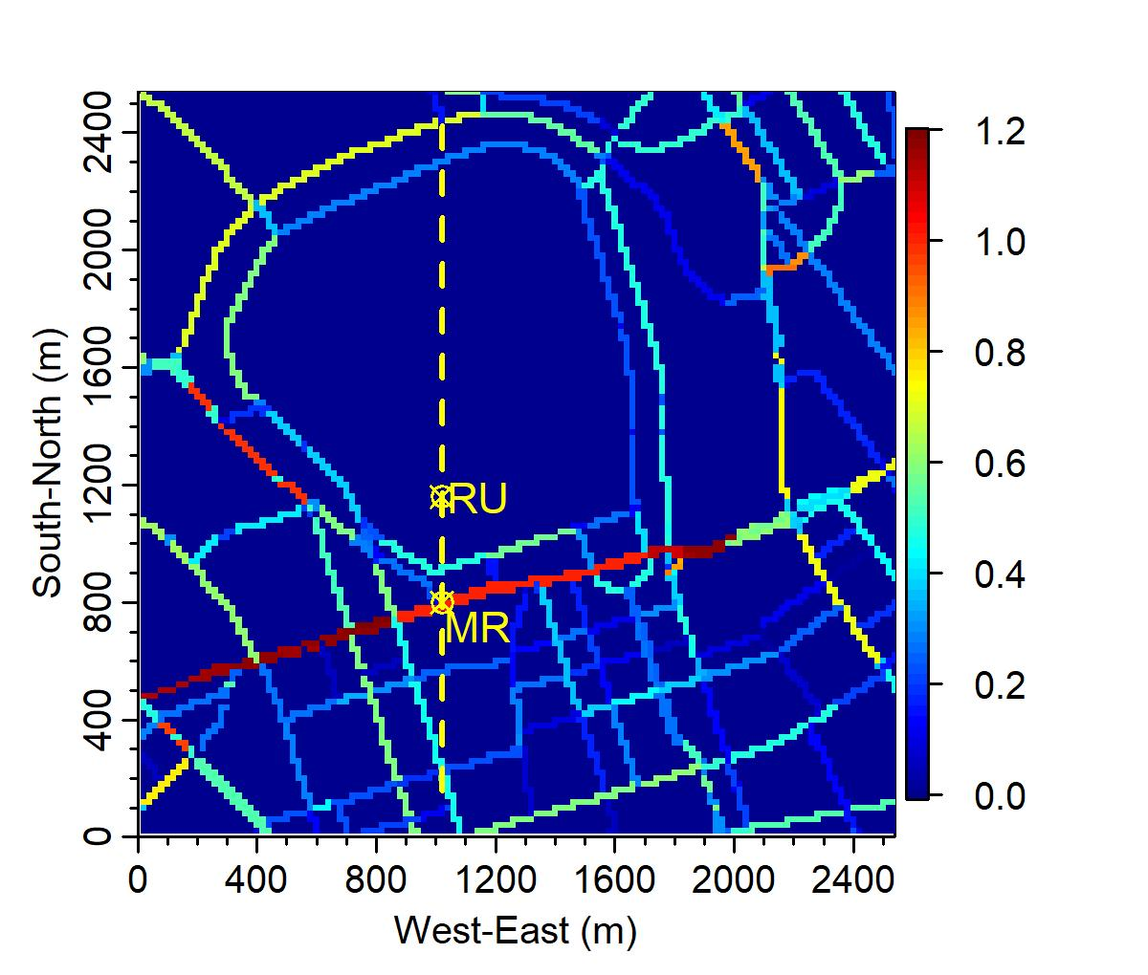
Figure 1. Traffic activity relative to Marylebone Road, based on Annual Average Daily Totals in 2013 for scaling purpose. The traffic activity map is based on the London Atmospheric Emissions Inventory (LAEI) 2013 (https://data.london.gov.uk/dataset/london-atmospheric-emissions-inventory-2013). Measurement locations Marylebone Road (MR) and Regent’s University (RU) are indicated. Thin yellow vertical line indicates location of north-south vertical slice in Figure 2.

- (b)
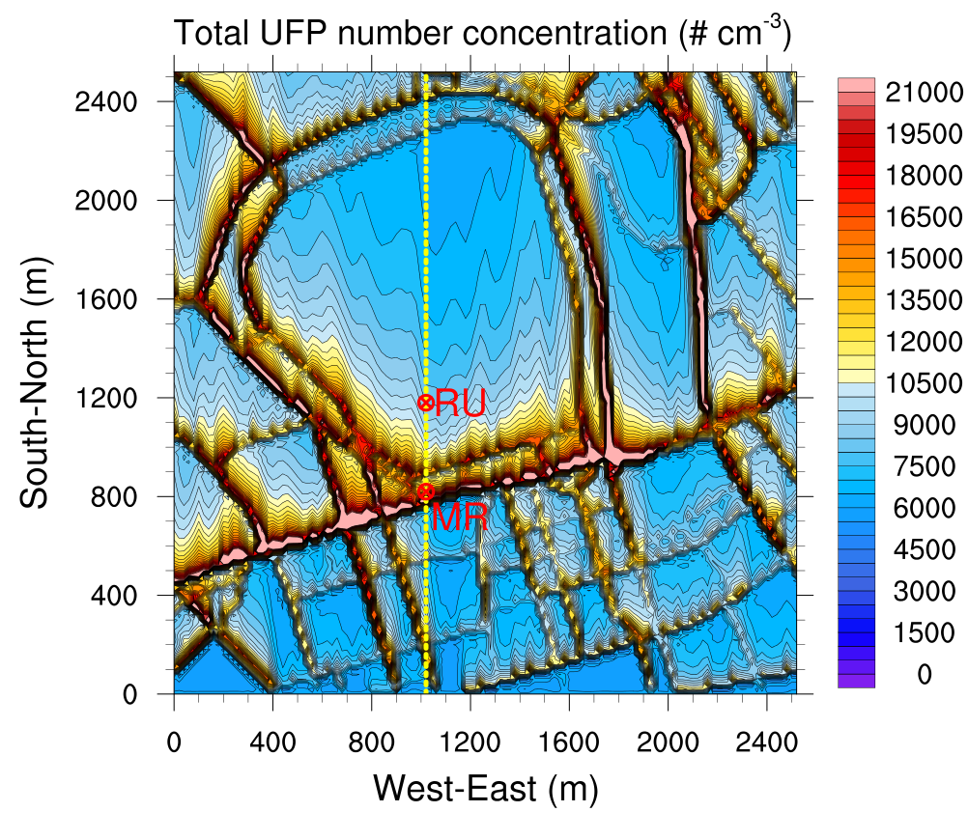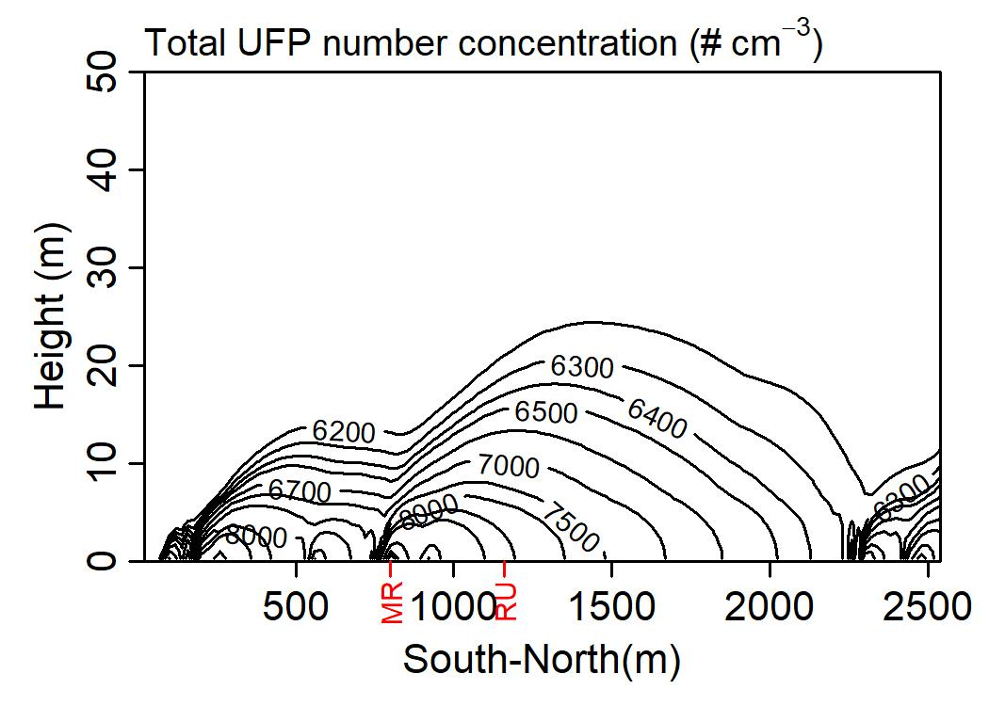
(c) (d)
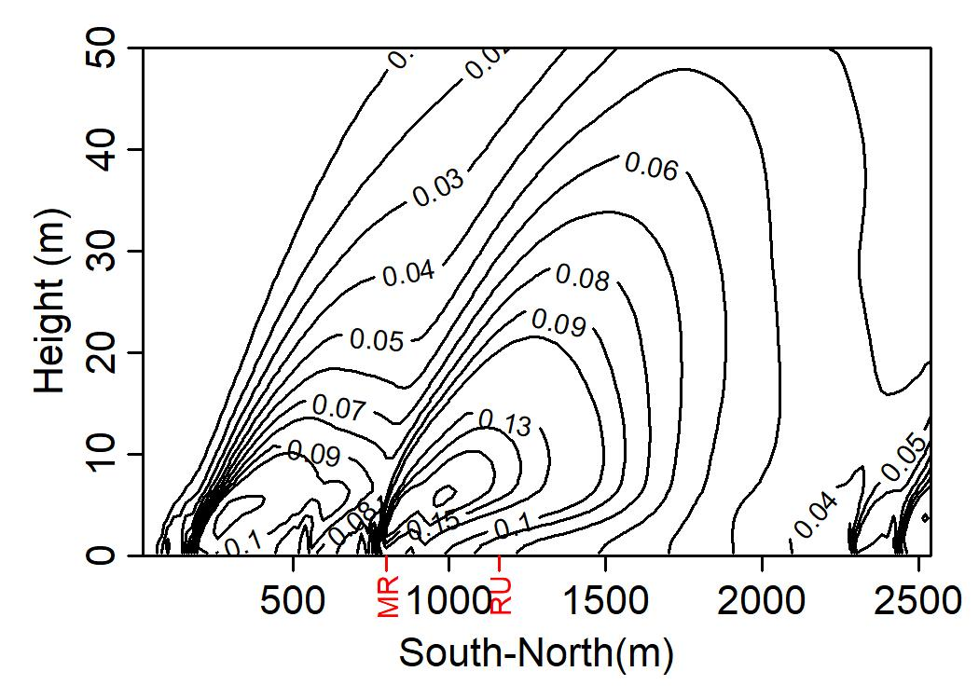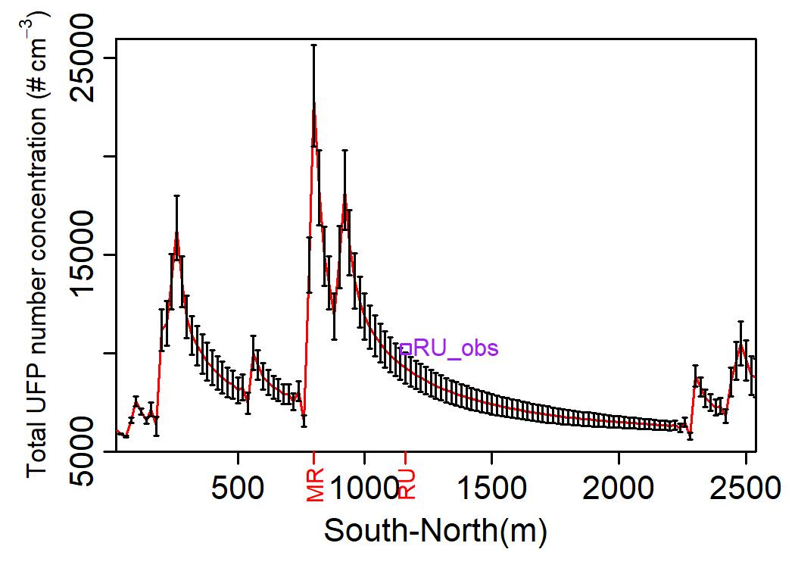
Figure 2. Total UFP number concentration (# cm⁻³): (a) Horizontal slice at the bottom level ($C_{m}$), (b) Vertical slice of mean concentration ($C_{m}$), (c) Vertical slice of the ratio of concentration fluctuation intensity to mean concentration ($C'/C_{m}$), and (d) ${ C}_{m}±C^{'}$ along South-North line (the square represents the RU measurement).

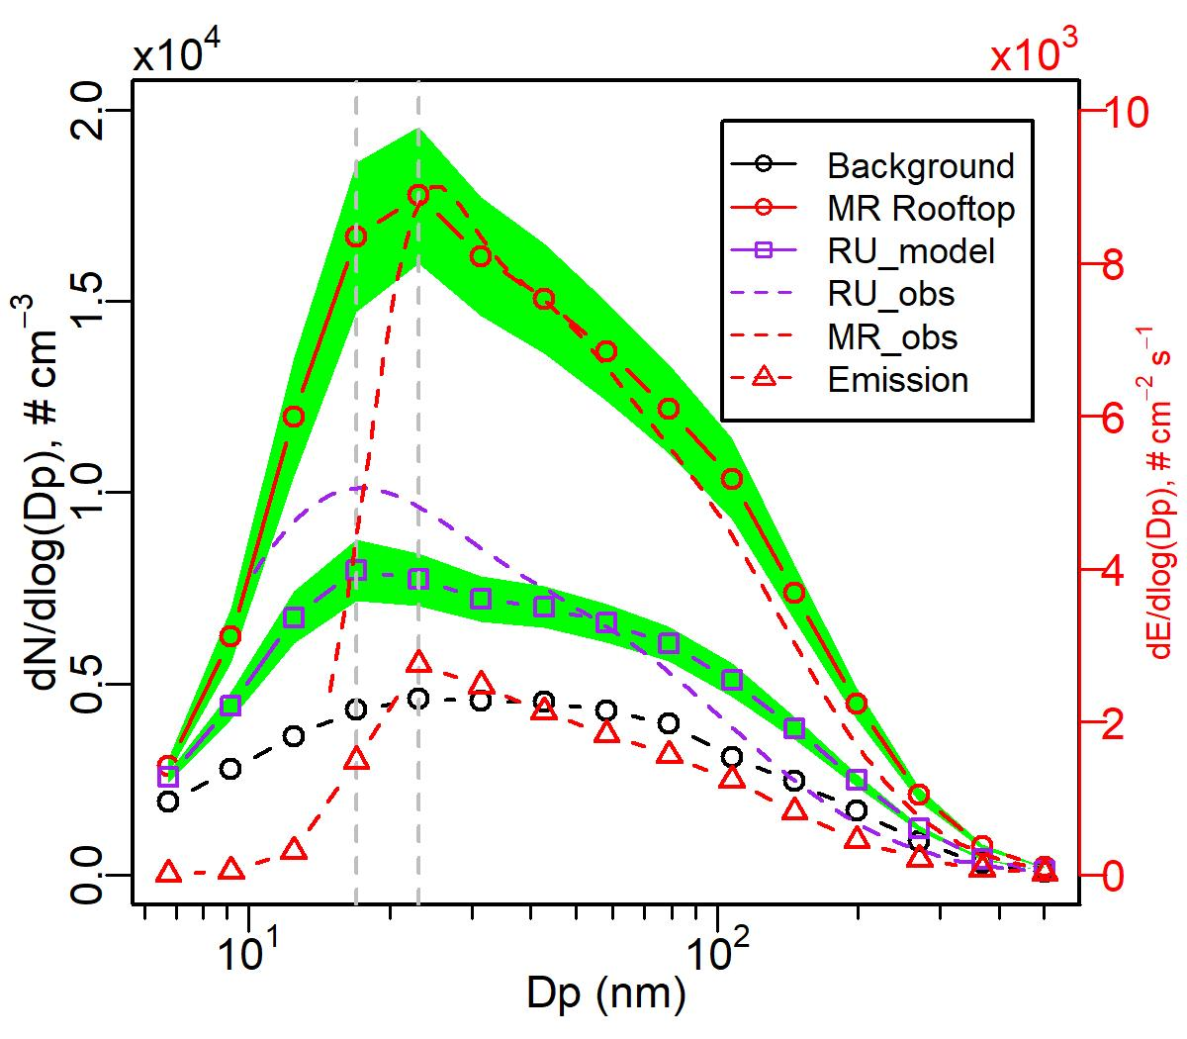
Figure 3. UFP number-size distribution dN/dlog(Dp) (# cm⁻³) at roof top of Marylebone Road (MR) and Regent’s University (RU). The shaded areas represent the fluctuation intensity. Vertical lines indicate the nucleation mode diameter at MR and RU.

(a)
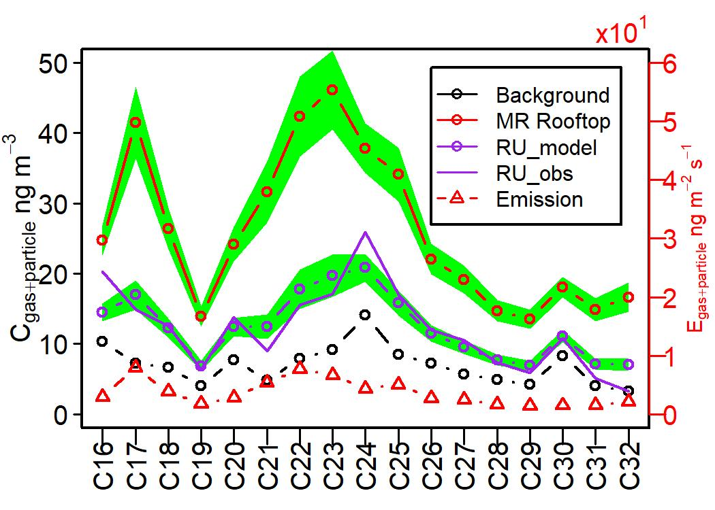
(b)
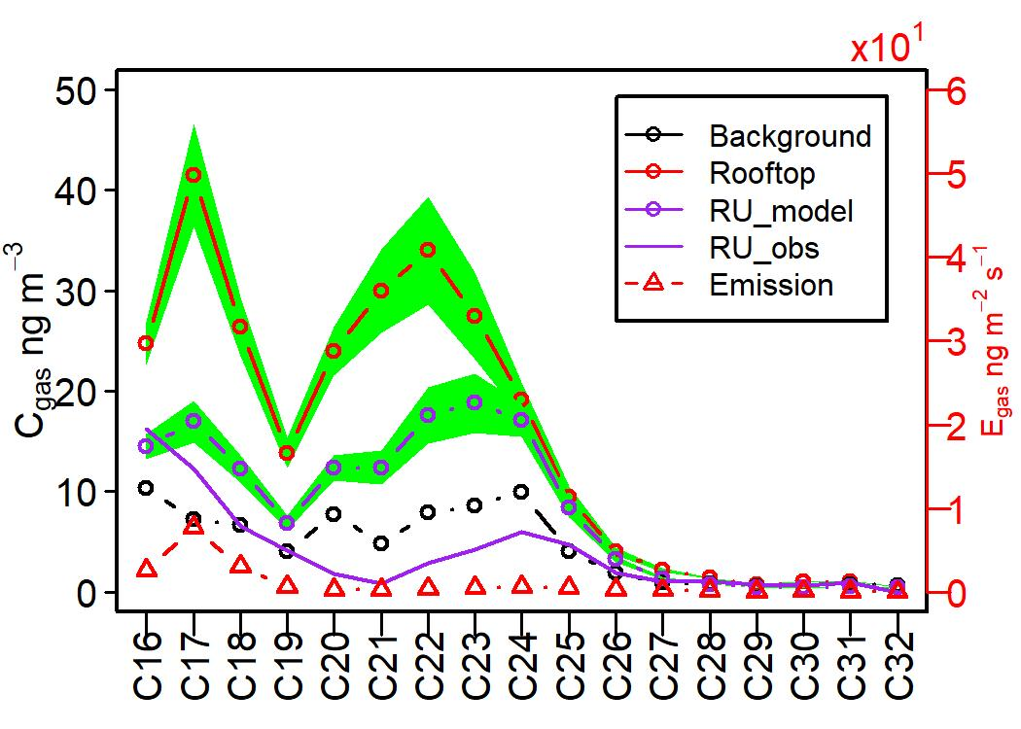
(c)
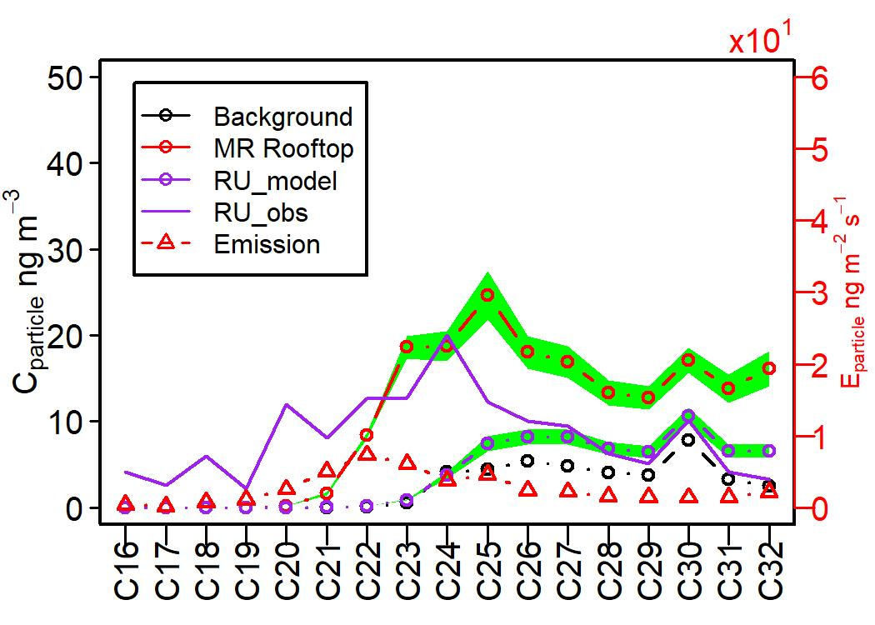
Figure 4. SVOCs concentration (ng m⁻³) at roof top of Marylebone Road and Regent’s University: (a) Sum of gas and particle concentrations; (b) Gas concentrations and (c) Particle concentrations,; The shaded areas represent the fluctuation intensity.
(a) Case “MR only”
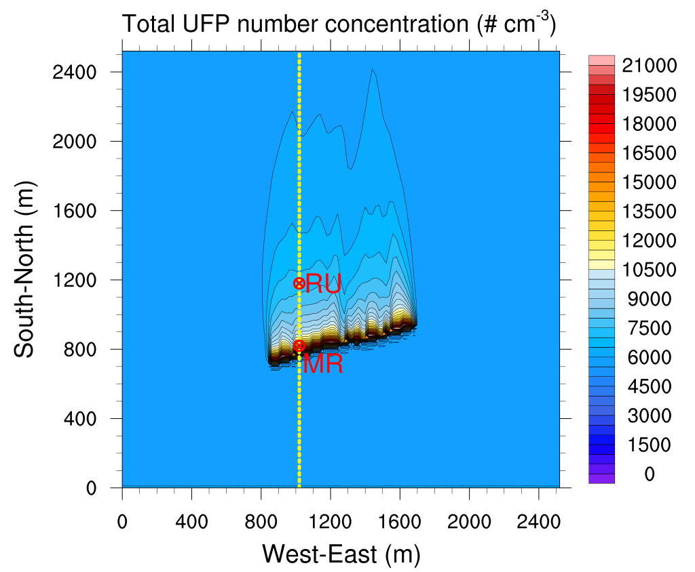
(b) Case “Others”
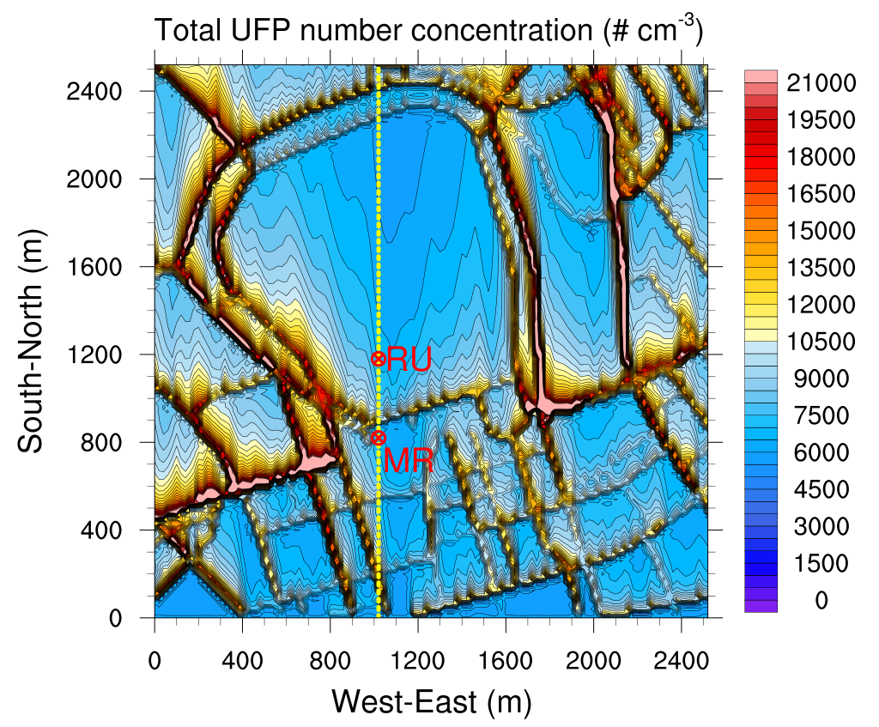
(c) All scenarios
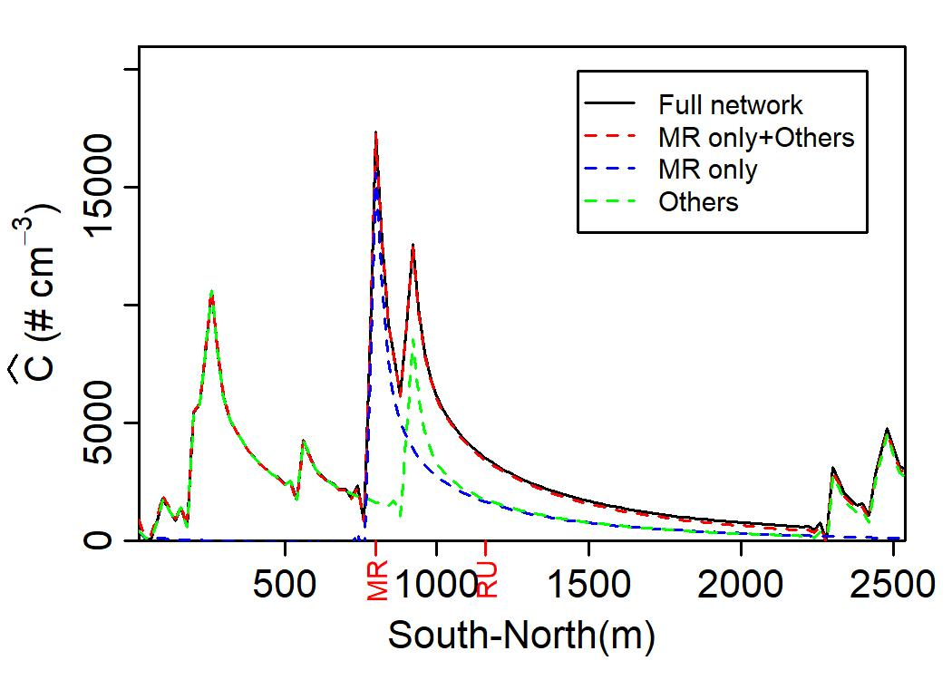
Figure 5. Horizontal slice of the total UFP number concentration $C_{m}$ (# cm⁻³) at the bottom level, (a) for Case “MR only”, (b) for Case “Others”, and (c) Traffic-induced $\hat{C}$ along South-North line for all scenarios.
(a) At MR rooftop (b) At RU
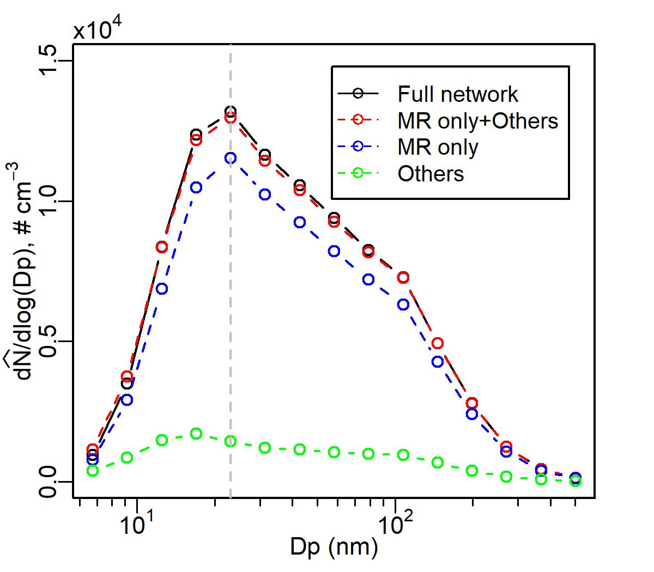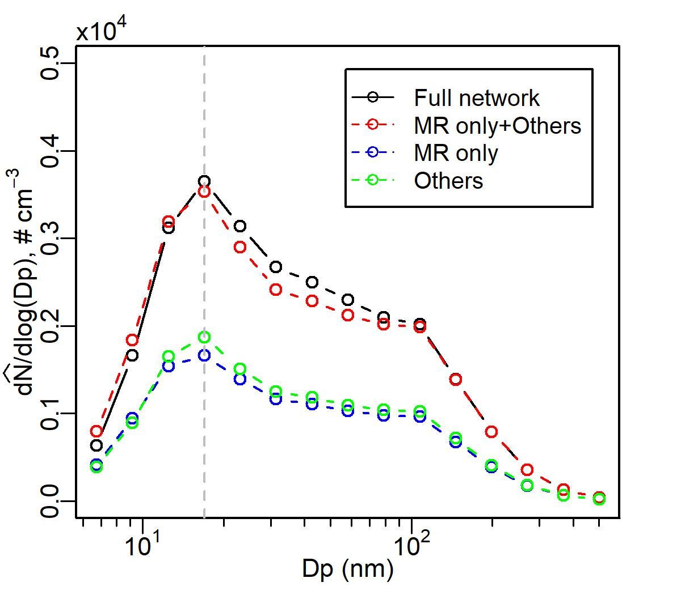
Figure 6. Traffic-induced UFP number-size distribution $d\hat{N}/dlog(Dp)$ (# cm⁻³) (a) at roof top of Marylebone Road and (b) Regent’s University for all scenarios (Cases “MR only”, “Others” and “Full network”).

(a) At MR rooftop (b) At RU
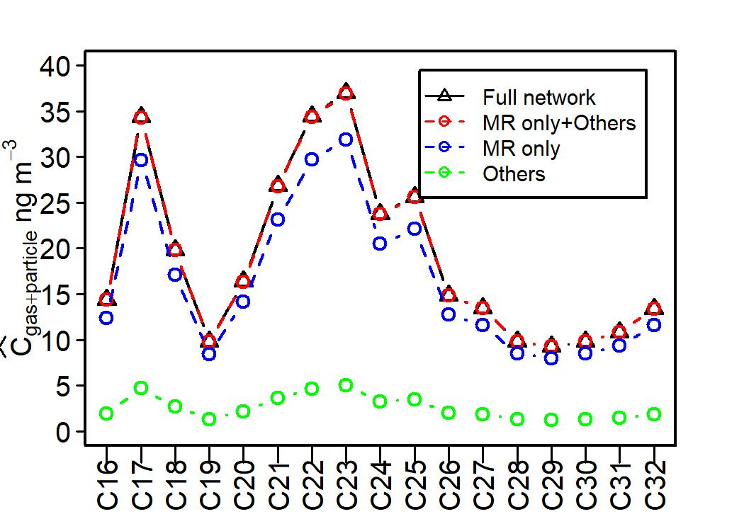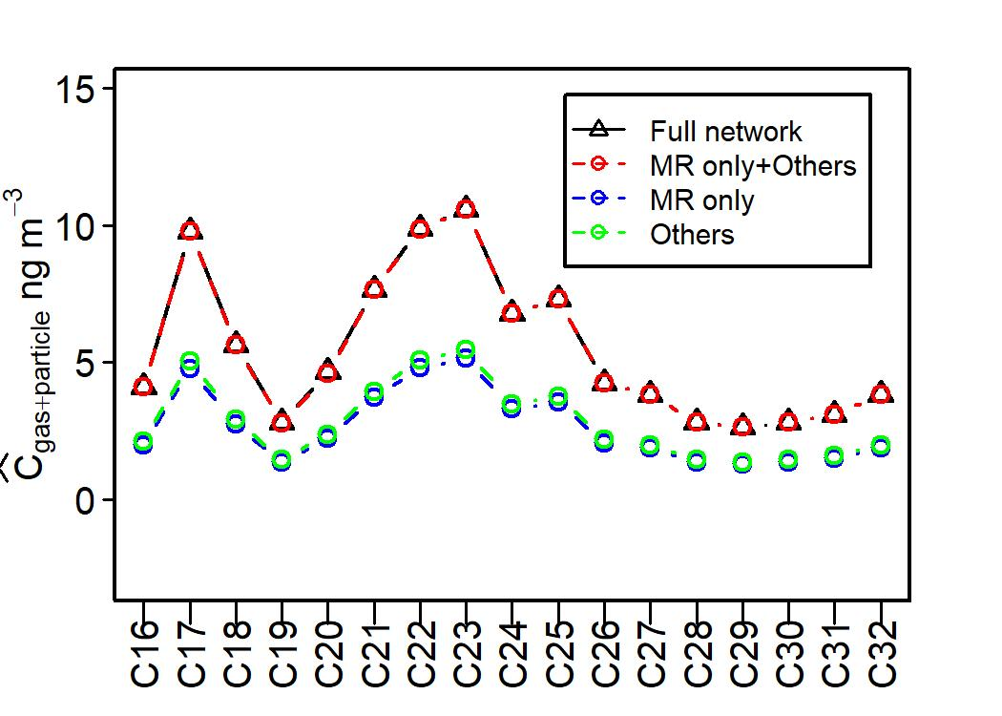
(c) At MR rooftop (d) At RU
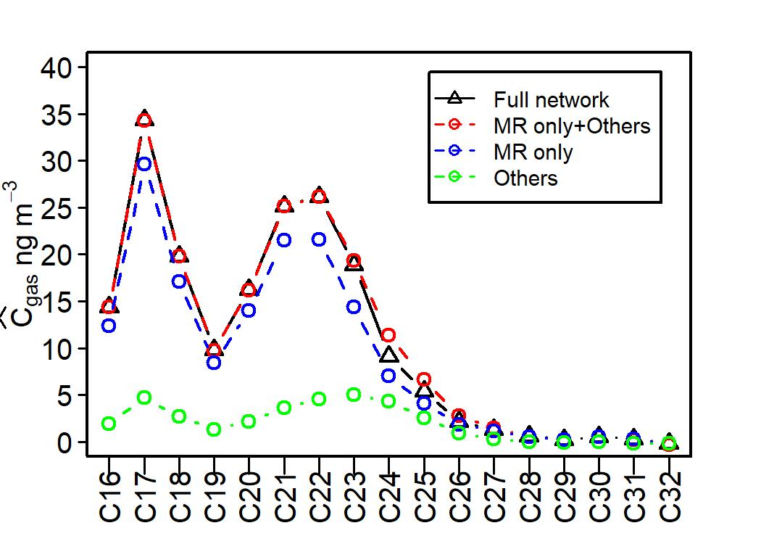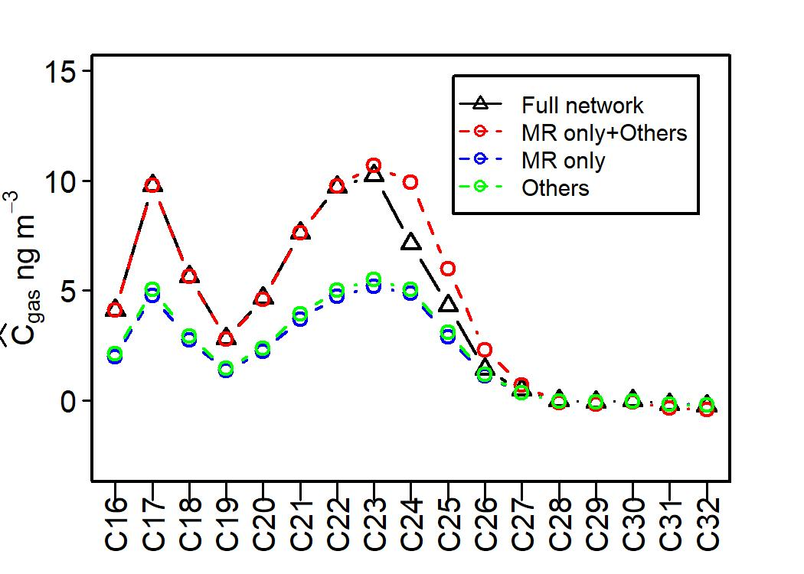
(e) At MR rooftop (f) At RU
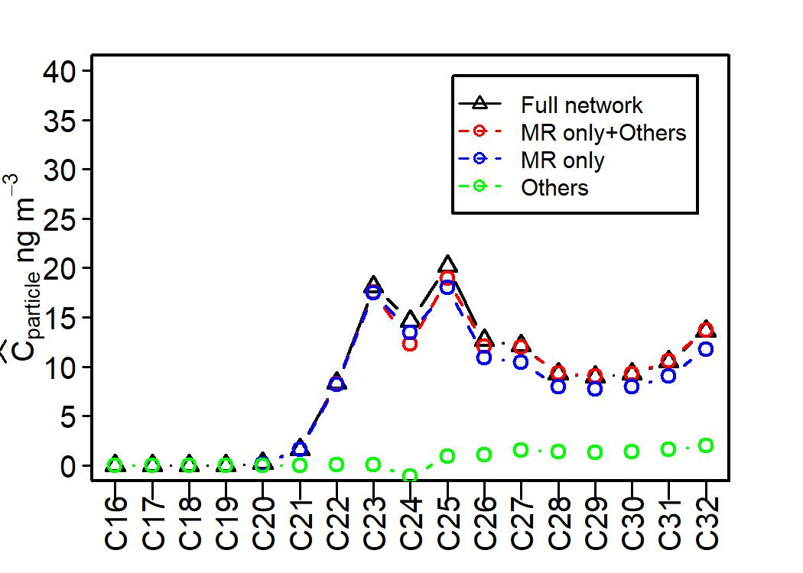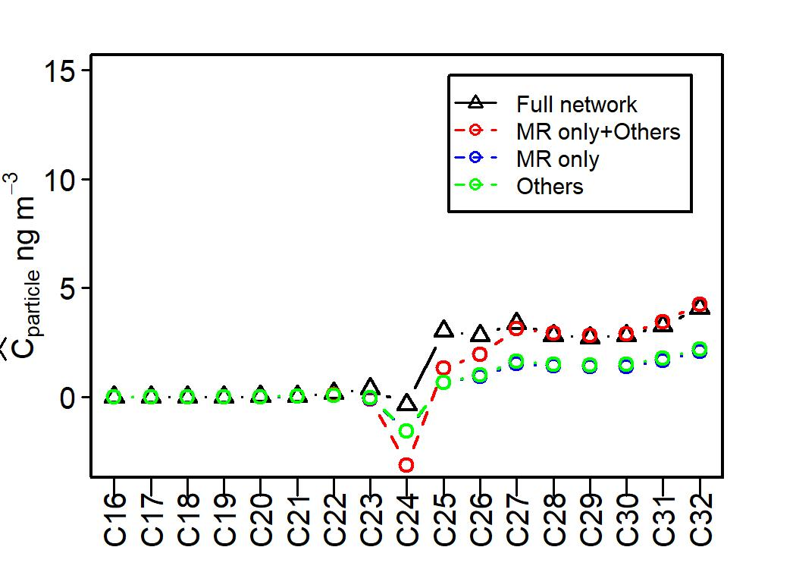
Figure 7. Traffic-induced SVOCs concentration (ng m⁻³) at roof top of Marylebone Road (a,c,e) and Regent’s University (b,d,f) for all scenarios (Cases “MR only”, “Others” and “Full network”).

References:
ACKERMANN, I. J., HASS, H., MEMMESHEIMER, M., EBEL, A., BINKOWSKI, F. S. & SHANKAR, U. 1998. Modal aerosol dynamics model for Europe: Development and first applications. Atmos. Environ., 32, 2981-2999.
ALAM, M. S., NIKOLOVA, I., SINGH, A., MACKENZIE, A. R. & HARRISON, R. M. 2019. Experimental vapour pressures of eight n-alkanes (C-17, C-18, C-20, C-22, C-24, C-26, C-28 and C-31) measured at ambient temperatures. Atmos. Environ., 213, 739-745.
ALAM, M. S., ZERAATI-REZAEI, S., LIANG, Z. R., STARK, C., XU, H. M., MACKENZIE, A. R. & HARRISON, R. M. 2018. Mapping and quantifying isomer sets of hydrocarbons ( >= C-12) in diesel exhaust, lubricating oil and diesel fuel samples using GC x GC-ToF-MS. Atmos. Meas. Tech. , 11, 3047-3058.
ALAM, M. S., ZERAATI-REZAEI, S., STARK, C. P., LIANG, Z. R., XU, H. M. & HARRISON, R. M. 2016. The characterisation of diesel exhaust particles - composition, size distribution and partitioning. Faraday Discuss., 189, 69-84.
ALONSO-BLANCO, E., GOMEZ-MORENO, F. J., ARTINANO, B., IGLESIAS-SAMITIER, S., JUNCAL-BELLO, V., PINEIRO-IGLESIAS, M., LOPEZ-MAHIA, P., PEREZ, N., BRINES, M., ALASTUEY, A., GARCIA, M. I., RODRIGUEZ, S., SORRIBAS, M., DEL AGUILA, A., TITOS, G., LYAMANI, H. & ALADOS-ARBOLEDAS, L. 2018. Temporal and spatial variability of atmospheric particle number size distributions across Spain. Atmos. Environ., 190, 146-160.
BAIK, J.-J., KANG, Y.-S. & KIM, J.-J. 2007. Modeling reactive pollutant dispersion in an urban street canyon. Atmos. Environ., 41, 934-949.
BISWAS, S., NTZIACHRISTOS, L., MOORE, K. F. & SIOUTAS, C. 2007. Particle volatility in the vicinity of a freeway with heavy-duty diesel traffic. Atmos. Environ., 41, 3479-3493.
CHIN, M., ROOD, R. B., LIN, S.-J., MÜLLER, J.-F. & THOMPSON, A. M. 2000. Atmospheric sulfur cycle simulated in the global model GOCART: Model description and global properties. J. Geophys. Res. Atmos. , 105, 24671-24687.
COMPERNOLLE, S., CEULEMANS, K. & MULLER, J. F. 2011. EVAPORATION: a new vapour pressure estimation methodfor organic molecules including non-additivity and intramolecular interactions. Atmos. Chem. Phys. , 11, 9431-9450.
CRILLEY, L. R., LUCARELLI, F., BLOSS, W. J., HARRISON, R. M., BEDDOWS, D. C., CALZOLAI, G., NAVA, S., VALLI, G., BERNARDONI, V. & VECCHI, R. 2017. Source apportionment of fine and coarse particles at a roadside and urban background site in London during the 2012 summer ClearfLo campaign. Environ. Pollut., 220, 766-778.
DALL'OSTO, M., THORPE, A., BEDDOWS, D. C. S., HARRISON, R. M., BARLOW, J. F., DUNBAR, T., WILLIAMS, P. I. & COE, H. 2011. Remarkable dynamics of nanoparticles in the urban atmosphere. Atmos. Chem. Phys. , 11, 6623-6637.
DEBRY, E., FAHEY, K., SARTELET, K., SPORTISSE, B. & TOMBETTE, M. 2007. Technical Note: A new SIze REsolved Aerosol Model (SIREAM). Atmos. Chem. Phys., 7, 1537-1547.
GEISER, M., ROTHEN-RUTISHAUSER, B., KAPP, N., SCHURCH, S., KREYLING, W., SCHULZ, H., SEMMLER, M., HOF, V. I., HEYDER, J. & GEHR, P. 2005. Ultrafine particles cross cellular membranes by nonphagocytic mechanisms in lungs and in cultured cells. Environ. Health Perspect., 113, 1555-1560.
HABRE, R., ZHOU, H., ECKEL, S. P., ENEBISH, T., FRUIN, S., BASTAIN, T., RAPPAPORT, E. & GILLILAND, F. 2018. Short-term effects of airport-associated ultrafine particle exposure on lung function and inflammation in adults with asthma. Environ. Int., 118, 48-59.
HARRISON, R. M., BEDDOWS, D. C. S., ALAM, M. S., SINGH, A., BREAN, J., XU, R. X., KOTTHAUS, S. & GRIMMOND, S. 2019. Interpretation of particle number size distributions measured across an urban area during the FASTER campaign. Atmos. Chem. Phys. , 19, 39-55.
HARRISON, R. M., JONES, A. M., BEDDOWS, D. C. S., DALL'OSTO, M. & NIKOLOVA, I. 2016. Evaporation of traffic-generated nanoparticles during advection from source. Atmos. Environ., 125, 1-7.
HARRISON, R. M., MACKENZIE, A. R., XU, H. M., ALAM, M. S., NIKOLOVA, I., ZHONG, J., SINGH, A., ZERAATI-REZAEI, S., STARK, C., BEDDOWS, D. C. S., LIANG, Z. R., XU, R. X. & CAI, X. M. 2018. Diesel exhaust nanoparticles and their behaviour in the atmosphere. Proc. R. Soc. A 474, 1-20.
JACOBSON, M. Z. 2001. GATOR-GCMM: A global- through urban-scale air pollution and weather forecast model 1. Model design and treatment of subgrid soil, vegetation, roads, rooftops, water, sea ice, and snow. Journal of Geophysical Research-Atmospheres, 106, 5385-5401.
JACOBSON, M. Z. 2005. Fundamentals of Atmospheric Modeling, New York, Cambridge University Press.
JACOBSON, M. Z., KITTELSON, D. B. & WATTS, W. F. 2005. Enhanced coagulation due to evaporation and its effect on nanoparticle evolution. Environ. Sci. Technol., 39, 9486-9492.
JACOBSON, M. Z. & SEINFELD, J. H. 2004. Evolution of nanoparticle size and mixing state near the point of emission. Atmos. Environ., 38, 1839-1850.
JONES, A. M. & HARRISON, R. M. 2006. Estimation of the emission factors of particle number and mass fractions from traffic at a site where mean vehicle speeds vary over short distances. Atmos. Environ., 40, 7125-7137.
KARL, M., KUKKONEN, J., KEUKEN, M. P., LUTZENKIRCHEN, S., PIRJOLA, L. & HUSSEIN, T. 2016. Modeling and measurements of urban aerosol processes on the neighborhood scale in Rotterdam, Oslo and Helsinki. Atmos. Chem. Phys. , 16, 4817-4835.
KARNEZI, E., RIIPINEN, I. & PANDIS, S. N. 2014. Measuring the atmospheric organic aerosol volatility distribution: a theoretical analysis. Atmos. Meas. Tech. , 7, 2953-2965.
KURPPA, M., HELLSTEN, A., ROLDIN, P., KOKKOLA, H., TONTTILA, J., AUVINEN, M., KENT, C., KUMAR, P., MARONGA, B. & JÄRVI, L. 2019. Implementation of the sectional aerosol module SALSA2.0 into the PALM model system 6.0: model development and first evaluation. Geosci. Model Dev., 12, 1403-1422.
KWAK, K. H. & BAIK, J. J. 2014. Diurnal variation of NOx and ozone exchange between a street canyon and the overlying air. Atmos. Environ., 86, 120-128.
MANIGRASSO, M., NATALE, C., VITALI, M., PROTANO, C. & AVINO, P. 2017. Pedestrians in Traffic Environments: Ultrafine Particle Respiratory Doses. Int. J. Environ. Res. Public Health, 14.
MCHUGH, C. A., CARRUTHERS, D. J. & EDMUNDS, H. A. 1997. ADMS-Urban: an air quality management system for traffic, domestic and industrial pollution. Int. J. Environ. Pollu. , 8, 666-674.
MUNIR, S. & HABEEBULLAH, T. M. 2018. Vehicular emissions on main roads in Makkah, Saudi Arabiaa dispersion modelling study. Arab. J. Geosci. , 11.
NIKOLOVA, I., MACKENZIE, A. R., CAI, X. M., ALAM, M. S. & HARRISON, R. M. 2016. Modelling component evaporation and composition change of traffic-induced ultrafine particles during travel from street canyon to urban background. Faraday Discuss., 189, 529-546.
OPPENHEIM, H. A., LUCERO, J., GUYOT, A. C., HERBERT, L. M., MCDONALD, J. D., MABONDZO, A. & LUND, A. K. 2013. Exposure to vehicle emissions results in altered blood brain barrier permeability and expression of matrix metalloproteinases and tight junction proteins in mice. Part. Fibre Toxicol., 10.
PACITTO, A., AMATO, F., SALMATONIDIS, A., MORENO, T., ALASTUEY, A., RECHE, C., BUONANNO, G., BENITO, C. & QUEROL, X. 2019. Effectiveness of commercial face masks to reduce personal PM exposure. Sci. Total Environ., 650, 1582-1590.
PUGH, T. A. M., CAIN, M., METHVEN, J., WILD, O., ARNOLD, S. R., REAL, E., LAW, K. S., EMMERSON, K. M., OWEN, S. M., PYLE, J. A., HEWITT, C. N. & MACKENZIE, A. R. 2012. A Lagrangian model of air-mass photochemistry and mixing using a trajectory ensemble: the Cambridge Tropospheric Trajectory model of Chemistry And Transport (CiTTyCAT) version 4.2. Geosci. Model Dev., 5, 193-221.
SAGER, T. M. & CASTRANOVA, V. 2009. Surface area of particle administered versus mass in determining the pulmonary toxicity of ultrafine and fine carbon black: comparison to ultrafine titanium dioxide. Part. Fibre Toxicol., 6.
SKAMAROCK, W. C. & KLEMP, J. B. 2008. A time-split nonhydrostatic atmospheric model for weather research and forecasting applications. J. Comput. Phys., 227, 3465-3485.
SOLAZZO, E., CAI, X. & VARDOULAKIS, S. 2008. Modelling wind flow and vehicle-induced turbulence in urban streets. Atmos. Environ., 42, 4918-4931.
STOCKER, J., HOOD, C., CARRUTHERS, D. & MCHUGH, C. 2012. ADMS-Urban: developments in modelling dispersion from the city scale to the local scale. Int. J. Environ. Pollu. , 50, 308-316.
TOPPING, D., BARLEY, M., BANE, M. K., HIGHAM, N., AUMONT, B., DINGLE, N. & MCFIGGANS, G. 2016. UManSysProp v1.0: an online and open-source facility for molecular property prediction and atmospheric aerosol calculations. Geosci. Model Dev., 9, 899-914.
WOJDYR, M. 2010. Fityk: a general-purpose peak fitting program. J. Appl. Crystallogr., 43, 1126-1128.
XU, R., ALAM, M. S., STARK, C. & HARRISON, R. M. 2019. Composition and emission factors of traffic- emitted intermediate volatility and semi-volatile hydrocarbons (C10-C36) at a street canyon and urban background sites in central London, UK. Atmos. Environ., https://doi.org/10.1016/j.atmosenv.2020.117448.
ZAVERI, R. A., EASTER, R. C., FAST, J. D. & PETERS, L. K. 2008. Model for Simulating Aerosol Interactions and Chemistry (MOSAIC). J. Geophys. Res. Atmos. , 113.
ZHANG, T. H., ZHU, Z. M., GONG, W., XIANG, H. & FANG, R. M. 2016. Characteristics of Fine Particles in an Urban Atmosphere-Relationships with Meteorological Parameters and Trace Gases. Int. J. Environ. Res. Public Health, 13.
ZHONG, J., NIKOLOVA, I., CAI, X., MACKENZIE, A. R., ALAM, M. S., XU, R., SINGH, A. & HARRISON, R. M. 2019. Traffic-induced multicomponent ultrafine particle microphysics in the WRF v3.6.1 large eddy simulation model: General behaviour from idealised scenarios at the neighbourhood-scale. Atmos. Environ., 2019.
ZHONG, J., NIKOLOVA, I., CAI, X., MACKENZIE, A. R. & HARRISON, R. M. 2018. Modelling traffic-induced multicomponent ultrafine particles in urban street canyon compartments: Factors that inhibit mixing. Environ. Pollut., 238, 186-195.

