Active-Screen Plasma Multi-Functionalization of Graphene Oxide for Supercapacitor Application
Zhiyuan Jing^{1*}, Shaojun Qi¹, Xiao Tao¹, Helong Yu², Wei Zhang³, Yulin Qiao⁴, Xiaoying Li¹, Hanshan Dong¹
1 School of Metallurgy and Materials, University of Birmingham, Birmingham B15 2TT, UK
2 National Key Laboratory for Remanufacturing, AAAF, Beijing, 100072, China
3 Jingjinji Institute of Remanufacturing Industry & Technology, Hebei 062450, China
4 National Engineering Research Center for Mechanical Product Remanufacturing, AAAF, Beijing, 100072, China

Abstract:
Supercapacitors have attracted much attention as energy storage device for its long cycle life and high power density. Graphene materials are competitive candidates as electrodes of supercapacitors for their high specific surface area, electrical conductivity and stability. Either heteroatoms doping or incorporation with metal/metal oxides have been reported effective in further improving the capacitive performance of graphene-based electrode. Here, an active-screen plasma (ASP) technique was applied on graphene oxide (GO) as a low temperature, environmentally friendly and one-step multi-purpose treatment. Characterization of ASP treated GO revealed reduction of GO, nitrogen doping mainly in graphitic N configuration, and incorporation of multiple metal element (Fe, Mn, and Cr). Both electrical and electrochemical properties were improved considerably, with sheet resistance decreased to ~1.1×10⁶ Ω sq⁻¹, only a fifth of that of GO, and a specific capacitance increased to ~20 F g⁻¹, four times that of GO. These results suggest advanced ASP technique a simple and facile way for a simultaneous reduction and nitrogen doping of GO, with incorporation of metal/metal oxides nanoparticles towards energy storage applications.
Key words: graphene oxide, active-screen plasma, supercapacitors, nitrogen doping, metal/metal oxide nanoparticles

- Introduction
Supercapacitors (SCs), also called electrochemical capacitors or ultracapacitors, have attracted great attention as an energy storage device [1]. Compared to batteries, SCs possess the advantages of long cycle life and high power density to meet the demand for fast charging. There are two types of SCs, according to the mechanism of charge-storage of supercapacitors: electrical double-layer capacitors (EDLCs), and pseudo-capacitors [2]. EDLCs stores the charge by ion adsorption while pseudo-capacitors by redox reactions. However, the relatively low energy density is one of the main drawbacks that prohibits the SCs in some applications. To improve the energy density of SCs, carbon materials with a porous structure have been widely used as the electrode for their large specific surface area (SSA) [3].
Graphene has been a popular candidate material for SCs electrode because of its high SSA, good electrical conductivity, and superior chemical stability [4]. The theoretic SSA of pure monolayer graphene can reach up to 2630 m² g⁻¹ [5], which is favorable for (non-Faradic) EDLCs. However, rather than using pristine graphene, researchers have found that graphene doped with such heteroatoms as N, B, and S can further improve the performance of SCs, because the heteroatoms can function as electron donors or acceptors that involve redox reactions, thus increasing the pseudo-capacitance [6]. Among them, N is the most commonly used one for its similar atomic size and strong valence bond with carbon, and hence favorable effect. Furthermore, nano-particles (NPs) of metal or metal oxide are widely used to improve the performance of supercapacitors, since the deposited NPs on graphene increase the SSA [7], and the transition-metal oxides improve the pseudo-capacitive performance [8].
Graphene oxide (GO) is a derivative of graphene with oxygen functional groups on it. Mostly, these oxygen functional groups are epoxy and hydroxyl groups on the plane and carboxyl, carbonyl and ester groups at the edge or defect areas [9]. This derivative of graphene can be produced using cost-effective Hummer’s method [10], with a much lower cost than pristine graphene. Besides, due to the hydrophilicity of oxygen functional groups, GO can disperse in aqueous solution without assistance of environmentally unfriendly surfactants, which make it more convenient than graphene in practical use. Meanwhile, GO is more suitable than pristine graphene as the start material for N doping, because nitrogen atoms tend to dope at active areas, such as the edges, vacancies and defected areas, which are rich in GO due to the oxygen functional groups [11]. Admittedly, GO is not as superior as pristine graphene in terms of electrical conductivity. However, the former possesses defects and functional group sites, which facilitate versatile and controllable functionalization, making GO/rGO advantageous for supercapacitor applications [12][13]. Especially, better electrical conductivity of rGO with some remaining functional groups enable rGO more suitable than GO as the raw material for the synthesize of supercapacitors.
There are several methods developed for the synthesis of N-doped graphene materials, and they can be divided into two categories: direct synthesis and post treatment [6]. As to direct synthesis of N-doped materials, chemical vapor deposition and arc discharge are two typical methods, but they are unsuitable for industrial application due to their low yield and high cost. For the post treatment, graphene or GO is processed mainly using thermal annealing, hydrothermal and plasma technique. In thermal annealing, high temperature around 800 ºC is required to trigger and boost the nitrogen doping [11]. As to hydrothermal treatment, the processing condition is mild, but it takes long time (usually around 10 h) [14]. In addition, the precursors commonly used for supplying N are hydrazine hydrate, urea, ammonia, organic amines and pyrrole, which are either toxic or unfriendly to the environment [15]. During the processing, the waste production is inevitable, requiring more effort for the disposal.
Alternatively, plasma techniques using ammonia or gas mixture containing nitrogen for N-doping of graphene materials overcomes the shortcomings of the aforementioned methods, because it takes much less time (only minutes for the plasma process itself), requires lower temperature (even room temperature in some cases) and consumes less energy [16]. The nitrogen content can also be controlled by altering the parameters involved, such as power, treatment time and bias [9,15]. Rybin et al. [16] used RF-discharge plasma treatment to dope graphene with nitrogen in ammonia gas, and the temperature was below 40 ºC for a duration between 2-80 min. Duan et al. [18] applied hollow cathode plasma for fabricating N doped 3D graphene framework. However, when it comes to the fabricating graphene materials with metal composites, normally metal precursors are needed as the source material to mix with GO before they get reduced together with the GO during plasma treatment [19]. For example, Wang et al. [20] dispersed GO in H₂PtCl₆ solution before plasma treatment to synthesize Pt NPs grown on the GO surface. Dao et al. [21] applied HAuCl₄·H₂O as the precursor for plasma processing with GO to obtain Au NPs and reduced GO hybrids. Wei et al. [22] chose AgNO₃ solution as the precursor for plasma process with GO. These metal salts contain Cl or NO₃⁻, so that toxic waste and by-products from the precursors will be produced during the synthesis process, which are major environmental concerns.
Active-screen plasma (ASP) is an advanced plasma technique that applies an active-screen into conventional DC plasma furnace, and the target sample is placed on an insulator in the active-screen. In this way, the active-screen rather than the sample acts as the cathode, so that some undesirable effects, such as edge effect, hollow cathode damage, and arcing can be avoided for a more homogeneous treatment [23]. Compared to DC plasma, ASP is also suitable for treating non-conductive materials. During ASP treatment, metals from the active-screen will also be sputtered off and deposited on the samples being treated. Thus, it would be a feasible technique to dope graphene materials with heteroatoms and composite metal/metal oxide particles in one go. Previously, due to the low treatment temperature, ASP was used to study its reduction effects on GO embedded in a polymer substrate [24]; ASP was also used to deposit metal NPs on carbon nanofibers [25]. However, there is so far, to the best of our knowledge, no work applying plasma technique for simultaneous N doping and hybridizing with metal/metal oxide NPs on graphene materials.
Herein, the effects of ASP treatment on GO film (ASP-GO) and its potential on supercapacitor application is reported. As a comparison, untreated GO (UN-GO) and thermally annealed GO (AN-GO) were prepared and tested. Sheet resistance, and electrochemical measurements including cyclic voltammetry (CV), electrochemical impedance spectroscopy (EIS) and galvanostatic charge/discharge (GCD) were conducted to assess the super-capacitive performance of GO films. The mechanism of ASP for the reduction, and nitrogen doping of GO and deposition of NPs on GO, as well as the improvement of super-capacitive performance, is discussed in this work.

- Materials and methods
  - Sample preparation
Supplied by Sigma-Aldrich Company Ltd. (Dorset, UK) (Product number: 777676), GO was diluted to 0.8 mg mL⁻¹ with deionized water. The diluted GO suspension was drop cast on silicon wafer, silicate glass piece, and fluorine-doped tin oxide (FTO) glass for the treatments. Specifically, 0.2 ml GO suspension was drop cast on silicate glass pieces (12.5 mm × 12.5 mm) for sheet resistance test, and 0.3 ml GO suspension on FTO glass (15.0 mm × 15.0 mm) for electrochemical property test for a better electrical signal transfer. After drop casting on the substrates, the GO suspension was dried in air at 85 ºC for 1 h, resulting in a film adhering to the substrates.
  - Active-screen plasma treatment
The setup of ASP treatment is demonstrated in Fig. 1. The DC plasma furnace (Klöckner Ionon GMBH, Bergisch Gladbach, Germany) was modified with a mesh cylindrical cage which is the so-called active-screen to house the samples. The cage is made of 316 Austenitic stainless steel, with the nominal composition as shown in Table 1. The samples were put on an insulated worktable at a floating potential, and the distance between the samples and cage lid was approximately 15 mm. The ASP treatment was conducted at 100 ºC for 1 h at the pressure of 0.75 mbar (75 Pa). The gases were mixture of nitrogen (25 %) and hydrogen (75 %). The treatment conditions were initially selected by referring to previous studies on ASP functionalization of other carbon-based nano-materials [7][24][26] and further optimized based on some preliminary trials for a notable improvement of performances.
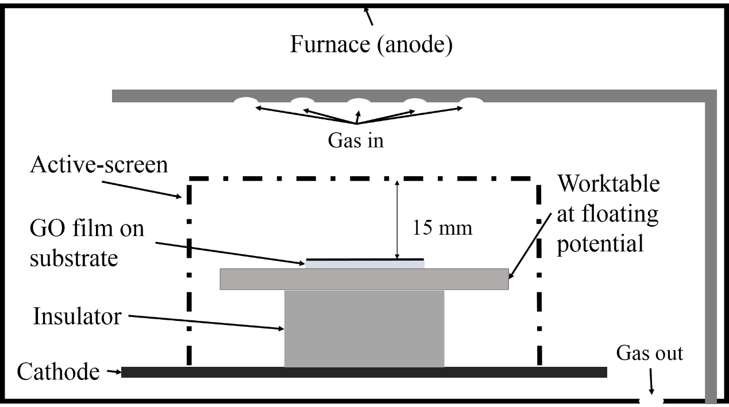
Fig. 1 Schematic of active-screen plasma treatment (not to scale)
Table 1 Composition (wt.%) of the 316 stainless steel cage
Ni | Cr | Mo | Mn | Si | C | P | S | Fe
10.0-14.0 | 16.0-18.5 | 2.0-3.0 | ≤ 2.00 | ≤ 1.00 | ≤ 0.08 | ≤ 0.035 | ≤ 0.03 | Balance

  - Annealing treatment
For comparison, the samples were also put in a tube furnace for annealing at the same temperature (100 ºC) and for the same duration (1 h) in an inert argon atmosphere, to explore the effect of temperature by itself on the GO.
  - Characterization
The surface morphology and elemental information of the GO samples were examined using a Philips XL-30 field emission scanning electron microscopy (FE-SEM), and the associated Oxford Inca energy dispersive X-ray spectroscopy (EDS). A Jeol 7000F was used for the surface morphology of ASP-GO with high-resolution, with associated Oxford AZtec EDS.
A Raman microscope (Renishaw inVia Reflex, laser power 3.5 W, laser wavelength 488 nm) was utilized to record the Raman spectra. Five scans were accumulated for each sample.
X-ray photoelectron spectroscopy (XPS) analysis was conducted in a Thermofisher ESCALAB 250 electron spectrometer equipped with a hemispherical sector energy analyser. A monochromatic Al Kα X-ray source was used for analysis to enhance the resolution. A source excitation energy of 15 keV, an emission current of 6 mA, an analyser pass energy of 50 eV with step size of 0.1 eV and dwell time of 50 ms were used throughout the experiments. The base pressure within the spectrometer during examinations was constantly lower than 5 × 10⁻¹⁰ mbar (5 × 10⁻⁸ Pa). The area of analysis was selected to be 500 μm in diameter. The peaks of the element spectra were deconvoluted using the associated Avatange (version 5.9918) software with the XPS instrument.
  - Electrical and electrochemical tests
The sheet resistance was measured using a four-point probe measurement system (Ossila, UK). The measurements were repeated for 5 times, and the average and standard deviation were reported
The electrochemical measurements were carried out to test the super-capacitive performances of the GO samples, as a half-cell in a three-electrode configuration, using a Gamry Interface 1000 potentiostat. A 3.5 % NaCl aqueous solution was used as the electrolyte for a higher ionic conductivity than organic electrolyte or ionic liquids. The sample as working electrode was exposed to electrolyte with a circle area of 0.503 cm² to participate in the electrochemical testing, and a silver tape was used to stick on the FTO glass and GO unexposed to the electrolyte, connecting GO to the lead to the potentiostat. The counter electrode was a platinum-coated rod of 6 mm in diameter, and the reference electrode was a saturated calomel electrode. Cyclic voltammetry (CV), electrochemical impedance spectroscopy (EIS) and galvanostatic charge/discharge (GCD) tests were performed at room temperature. The diagrammatic setup of the three-electrode configuration used for the electrochemical tests is shown in Fig. 2.
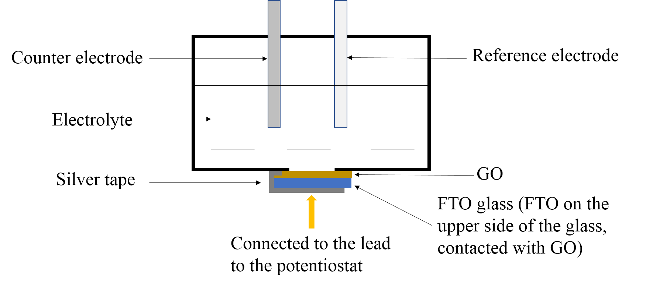
Fig. 2 Diagrammatic setup of the three-electrode configuration used for the electrochemical tests (not to scale)
The CV tests were conducted between -0.1 V and +0.9 V, both vs. reference electrode, and the scan rate differed at 100, 50, 20, 10 and 5 mV s⁻¹. The capacitance and specific capacitance were calculated by Equations 1 and 2, respectively, where C and Cs are capacitance and specific capacitance, respectively, Q is the charge accumulated during the cycle period, I is the instantaneous current, U is the applied potential, v is the scan rate and m is the mass of the tested sample.
$C=\frac{Q}{2∆U}=\frac{\int{I} dU}{2v×∆U}$ (1)
$C_{s}=\frac{C}{m}$ (2)
The EIS tests were performed at frequencies between 0.1 MHz and 0.01 Hz about the open circuit potential with a sinusoidal perturbation of 10 mV. The GCD was conducted and the samples were tested at a constant current of 100 mA within the potential range from -0.1 V to 0.9 V.

- Results
  - Morphology of GO film and sheet
The morphologies of GO drop casting on silicon wafer before and after annealing or ASP treatment are illustrated in Fig. 3(a-c). It is clear that the films on silicon wafer substrate are corrugated, like a silk veil. The observed wrinkles are characteristic feature of GO film spreading out on silicon wafer substrate [27]. There seems no noticeable difference in the low-resolution SEM morphology images of GO before (Fig. 3a) and after the annealing (Fig. 3b) or plasma treatments (Fig. 3c). However, when observed using Field emission SEM with high resolution, as shown in Fig 3(d), nano-particles (NPs) were found on the surface of ASP-GO. These deposited particles are very fine and the SEM/EDS line scan along a deposited particle revealed a high intensity of Fe element, as shown in Fig.3(e). Therefore, it can be deducted from Fig.3(e) that these very fine particles observed under high resolution SEM on the ASP-GO are metal NPs (<10nm) sputtered off from the metal active careen during the ASP treatment.
Fig. 4 compares the light elemental composition spectra of GO before and after the treatments. It can be seen from Fig. 4 that relative to the intensity of carbon, the intensity of the oxygen peak for the plasma treated ASP-GO is much lower than for the untreated UN-GO and argon annealed AN-GO. This comparatively reduced oxygen peak intensity is an indication of GO reduction by the ASP treatment. A small nitrogen peak was also observed from the spectrum for the ASP-GO, suggesting that the active screen plasma treated ASP-GO is doped with nitrogen.
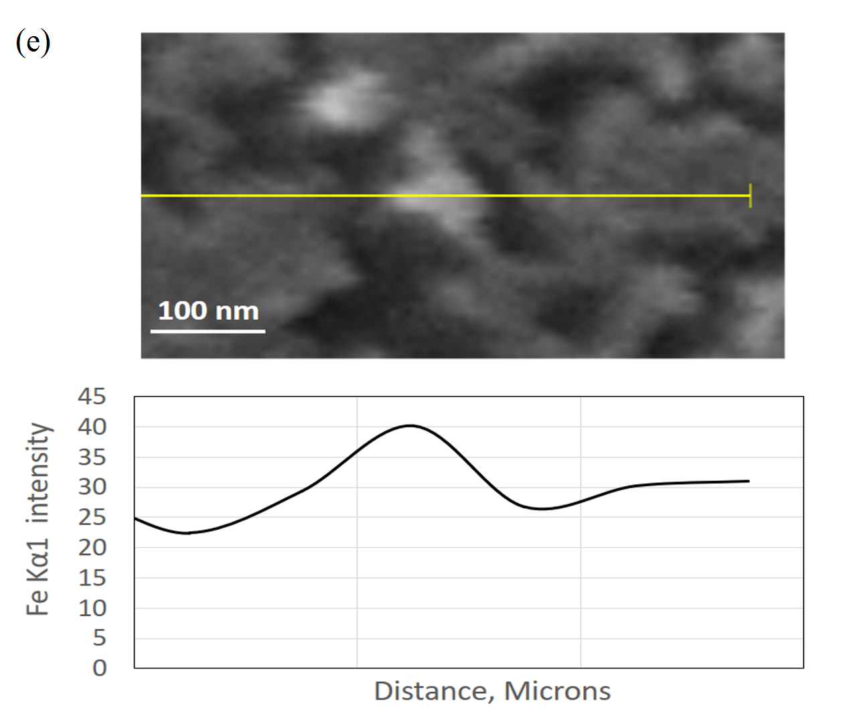
Fig. 3 SEM morphology of (a) UN-GO, (b) AN-GO, (c) ASP-GO, (d) high-resolution of ASP-GO (deposited nanoparticles are denoted by circles), and (e) SEM/EDS line scan along a deposited particle indicating a high intensity of Fe element at the particle

Fig. 4 EDS spectra of UN-GO, AN-GO, ASP-GO
  - Raman spectroscopy
Raman spectrum is an effective measurement to characterize the structure of graphene materials [28]. G peak corresponds to the high-frequency E_{2g} phonon at Brillouin zone center Γ of graphene, which makes it the most prominent and characteristic peak of graphene. D peak is associated with the defects and disorders of graphene structure. Thus, the ratio of intensity of D peak and G peak (I_{D}/I_{G}) is widely used to determine the graphene structure in terms of the defects and disorders that result from its oxidation and doping, and a smaller I_{D}/I_{G} suggests fewer defects of the graphene structure [29]. However, D peak arises from the breathing modes of six-atom rings, which means that only defects in crystalline region of sp² hybrid graphitic carbon can cause the increase of I_{D}/I_{G}, while amorphous carbon in sp³ hybrid cannot contribute to a higher I_{D}/I_{G}.[30] Thus, I_{D}/I_{G} may decrease with a rise in defects when crystalline graphite turns to an amorphous carbon structure, as sp² rings of graphitic structure are damaged, impairing the intensity of D peak [31]. I_{D}/I_{G} only increases when the defects related to the sp² hybrid graphitic carbon ring appears and increase. Therefore, the slight increase in I_{D}/I_{G} may suggest that the average size decreased whilst the number of the sp² aromatic rings increased upon reduction [32][33]. Full-width at half-maximum of G peak (FWHM(G)) is an indication of disorder of graphene as well and always increases with disorder [34].
The Raman spectra of UN-GO, AN-GO, and ASP-GO were shown in Fig. 5, with a table inset showing the FWHM of G peak and I_{D}/I_{G}. D and G peaks are positioned around 1360 cm⁻¹ and 1560 cm⁻¹, respectively. The I_{D}/I_{G} of UN-GO is 0.86, but it received a minor increase to 0.88 for both AN-GO and ASP-GO. As to AN-GO, this can be explained by the transformation from sp³ amorphous carbon into sp² rings with defects, attributed to the mild temperature increase of the annealing treatments. The decrease of FWHM(G) of AN-GO from 92 cm⁻¹ to 84 cm⁻¹ echo this hypothesis, indicating the reduction in disorders. As to ASP-GO, although it is commonly known that the doping of nitrogen will increase the I_{D}/I_{G} value significantly [35], the minor increase of I_{D}/I_{G,} similarly to reference (by Tao, et al. from 0.858 to 0.883) [36], could be attributed to a different mechanism. The reason can be contributed from the superimposed effect of reduction and the N doping by the ASP. The transformation from amorphous carbon into graphitic carbon, firstly, would increase the ratio of I_{D}/I_{G} as already discussed above; secondly, the reduction of GO decrease the defects of sp² hybrid carbon ring, due to a superior reduction effect of ASP treatment, and decrease the ratio of I_{D}/I_{G}; thirdly, N doping increase the ratio of I_{D}/I_{G}. All these three factors result in the final minor increase of I_{D}/I_{G}. Similarly, the decrease of FWHM(G) due to the reduction is compensated by the introduction of disorder associated with nitrogen-doping of the GO, and increases to 91.
Fig. 5 Normalized Raman spectra of GO before and after treatments
  - XPS analysis
XPS was carried out to examine the bonding status of elements in the three samples, and the atomic concentration of elements are shown in Table 2. It can be seen from Table 2 that after ASP treatment nitrogen content was significantly increased and metal elements Fe, Cr and Mn were detected; it is also noted that oxygen content was decreased by annealing treatment but increased by ASP treatment. These changes will be interpreted below in conjunction with the analysis of the XPS spectra. The relatively high level of sulfur detected from ASP-GO is most likely related to contamination due to its exposure to the air after the treatment although more work is needed to identify the source.
High-resolution C1s spectra are shown in Fig. 6(a-c). From the high resolution C1s spectrum, C-C, C-OH, C=O, C-O, O-C=O and C=N can be deconvolved out at 284.6, 286.9, 287.8, 286.3, 288.9, and 285.4 eV, respectively [37]. These different bindings suggest that the oxygen functional groups in GO mainly consist of hydroxyl, carbonyl, and carboxyl groups. The peak intensities of different carbon bonding vary, indicating the difference of content, and the percentage of the components are shown in Table 3. The peak of C-OH with the highest intensity in UN-GO indicates that hydroxyl is the most common form of oxygen functional groups. This peak gets attenuated in AN-GO and even weaker in ASP-GO, suggesting the decreasing of oxygen content in GO, i.e. reduction of GO. This can be confirmed by the proportions of C-C and C-OH in Table 3. The contents of C-C in high-resolution C 1s spectrum of UN-GO, AN-GO and ASP-GO are 44.1, 53.1, and 59.6 %, respectively, and those of C-OH are 41.9, 28.5, and 6.6 %, respectively. The highest percentage of C-C indicates the conjugated graphitic domain of GO. The increase of C-C after the treatments suggests the restoration of sp² hybrid structure of graphene plane. The decrease of C-OH in AN-GO indicates the reduction of GO. The further decrease of C-OH in ASP-GO indicates ASP treatment is superior to annealing in terms of GO reduction. Moreover, a boost of C=N from the 0.8 % for UN-GO to 19.9 % for ASP-GO, as well as the ratio of nitrogen to carbon from 0.017 to 0.303 implies the nitrogen doping of GO during ASP treatment.
The high-resolution N1s XPS spectrum of ASP-GO is shown in Fig. 6(d). For the N1s spectrum of ASP-GO, deconvolved peaks at 399.8 and 401.8 eV correspond to pyrrolic N and graphitic N, with percentages of 13.4 and 86.6 %, respectively, suggesting the GO being N-doped mainly in the form of graphitic N with a minority of pyrrolic N. However, it is not clear for the reason why another commonly configuration: pyridinic N, is not detected here [38]. Since graphitic N substitutes carbon in graphitic lattice on the basal plane, while pyrrolic N connects with two carbon atoms at the edge or vacancy areas in the form of a pentagonal ring [39], the dominance of graphitic N suggests that the nitrogen doping mainly took place in the planar domain of GO.
Apart from C and N, metal elements (Fe, Cr, Mn) were detected only in ASP-GO sample, with the proportions of these elements being 2.2, 0.6, and 0.2%, respectively. The existence of these metal elements which are major elements in the stainless steel screen once again indicates that metal elements from the active-screen were sputtered off and then deposited onto the GO sample during the ASP treatment [24]. The increase of O content from 36 % to 46.9% in ASP-GO could be mainly attributed to the metals in oxide states. However, it is difficult to conclude here if the metal oxides are formed during the ASP process with oxygen functional groups on GO or during the exposure to the air after the treatment. In addition, XPS revealed these metal elements are not in nitride states. This is mainly because the temperature in ASP process is controlled at 100 ºC, and hence no measurable metal nitrides could form at this very low temperature from the thermodynamics point of view.
Fig. 6 High-resolution XPS spectra of C1s of (a) UN-GO, (b) AN-GO, (c) ASP-GO and (d) N1s of ASP-GO
Table 2 Atomic Concentration (%) of the elements and ratio of N to C
 | C | N | O | S | Cr | Mn | Fe | N/C
UN-GO | 60.3 | 1.0 | 36.4 | 2.3 | / | / | / | 0.017
AN-GO | 64.9 | 2.8 | 30.9 | 1.4 | / | / | / | 0.043
ASP-GO | 28.7 | 8.7 | 49.5 | 9.9 | 0.7 | 0.2 | 2.3 | 0.303

Table 3 Percentage (%) of the components of C, N
 | C Components |  |  |  |  |  | N Components
 | C-C | C=N | C-O | C-OH | C=O | O-C=O | N-Pyrrolic | N-Graphitic
UN-GO | 44.1 | 0.8 | 3.3 | 41.9 | 7.4 | 2.5 | 20.0 | 80.0
AN-GO | 53.1 | 3.0 | 7.4 | 28.5 | 5.1 | 2.9 | 7.4 | 92.6
ASP-GO | 59.6 | 19.9 | 5.9 | 6.6 | 4.0 | 4.0 | 13.4 | 86.6

  - Electrical performance
Fig. 7 shows the sheet resistance of GO before and after the annealing and plasma treatments. As shown in Fig. 7, The sheet resistance of the untreated GO film is around 5.2×10⁶ Ω sq⁻¹, and the annealing treatment reduced the sheet resistance to about 1.9×10⁶ Ω sq⁻¹, approximately a third of the initial value. The decrease of sheet resistance of AN-GO can be attributed to the reduction of GO, consistent with similar studies in the literature [40]. The sheet resistance of GO film after the ASP treatment was further decreased to around 1.1×10⁶ Ω sq⁻¹, only about one-fifth of the sheet resistance of UN-GO, which means that ASP treatment is more effective in improving the electrical conductivity of GO than annealing treatment. The superiority of electrical property of ASP-GO to AN-GO can be contributed to a further reduction of GO, as indicated in XPS results, as well as the nitrogen doping of GO [9]. The extra electrons in nitrogen after covalently bonding with carbon are free charge carriers that can improve the electrical performance of GO [41].
Fig. 7 Sheet resistance of GO before and after treatments
  - Electrochemical performance
The electrochemical performances of UN-GO, AN-GO, and ASP-GO samples were evaluated in cyclic voltammetry (CV) test, and the results are shown in Fig. 8. All the CV curves at low scan rates exhibit quasi-rectangular shapes, indicating capacitive behavior [42]. UN-GO curves show the highest distortion and smallest area while ASP-GO maintains the best quasi-rectangle shape with the largest area. The shape retention and a larger area of the treated GO samples, ASP-GO in particularly, suggests their superior capacitive performance. A broadening of the capacitive current can be found near 0.8 V of ASP-GO but not shown on the UN-GO or AN-GO. The peak broadening may come from the Faradaic redox responses of GO and metal oxides, which means that a pseudocapacitive charging may have occurred during the voltammetry cycle. This could be ascribed to both the N-doping formed and the incorporation of transition metal oxides during the ASP treatment [43]. The specific capacitance results calculated from the curves using Equation 1 are shown in Fig. 7(d). The specific capacitances decreased with the increasing scan rates for all the samples tested. At a scan rate of 5 mV s⁻¹, the specific capacitance of ASP-GO reached almost 20 F g⁻¹, nearly 4 times that of UN-GO and 1.5 times that of AN-GO.
Fig. 8 CV curves of (a) UN-GO, (b) AN-GO, (c) ASP-GO, and (d) the specific capacitance at different scan rates
Electrochemical impedance spectroscopy (EIS) tests were also conducted to further investigate the electrochemical performance of these GO samples. Fig. 9 shows the Nyquist plot of the EIS result, with a Randles circuit model inset, and Table 4 exhibits some of the parameters of the equivalent circuit fit of the EIS results. Nyquist plot for a supercapacitor can be divided into two parts. The straight segment at low frequencies is related to the Warburg finite-length diffusion stage, while the diameter of semi-circle at high frequency region indicates the charge transfer resistance (R_{ct}) [44]. The smallest semi-circle of ASP-GO implies the fastest charge diffusion in the charging/discharging process. An ideal supercapacitor should show a small R_{ct}, i.e. a small semi-circle. Equivalent series resistance (ESR) includes electrolyte resistance, electrode resistance, and contact resistance between the electrode and the current collector [45]. For ASP-GO, the diameter of the semi-circle and the intercept of the plot to the x-axis were both the smallest, which means the smallest R_{ct} and ESR of the system. This is confirmed in Table 4, as the R_{ct} and ESR of ASP-GO are 2.55 kΩ and 0.06 kΩ, respectively, much lower than those of UN-GO (15.82 kΩ and 0.64 kΩ) and AN-GO (5.70 kΩ and 0.25 kΩ). This also agrees with the sheet resistance measurement results (Fig. 7), indicating a better effect on improving the electrical properties of GO by ASP treatment than by annealing treatment, because of both a further reduction and nitrogen doping effect. In addition, in the low frequency region, the vertical lines that parallel to the imaginary axis of both AN-GO and ASP-GO also indicated a capacitive characteristic [46]. The corresponding Bode plots are shown in Fig.10. At the highest frequency, the phase angle reaches nearly 0 º, and the Bode magnitude showed a plateau corresponding to ESR. With the decrease of frequency, the phase angle decreases to the lowest point, at which the Bode magnitude shows a slope, and the corresponding impedance indicate the R_{ct}. The results indicate the same as the Nyquist plot.
Fig. 9 Nyquist plot of untreated, annealed and ASP treated GO sample. Inset is the electric circuit analog
Table 4 Parameters of the equivalent circuit fit of the EIS results
 | ESR (kΩ) | R_{ct} (kΩ) | Goodness (×10⁻³）
UN-GO | 0.64 | 15.82 | 2.70
AN-GO | 0.25 | 5.70 | 1.07
ASP-GO | 0.06 | 2.55 | 0.76

Fig. 10 Bode plot of (a) untreated, (b) annealed and (c) ASP treated GO sample
Further comparison was conducted by galvanostatic charge/discharge test, and the results are shown in Fig. 11. The IR (Ohmic) drop obviously reduced after both treatments, with the ASP treated GO showing the smallest IR drop. Since IR drop is an indication of the energy loss caused by internal resistance [47], the smallest IR drop value for ASP-GO suggests that its internal resistance is the smallest and the energy lost during the charge-discharge process the least. This is consistent with the EIS results. In addition, the charge and discharge lines are nearly symmetrical, indicating the feasibility for supercapacitor application. However, the charge/discharge plot is not exactly an isosceles triangle, suggesting some pseudocapacitive character in the electrode [43]. The charge/discharge time of ASP-GO is the longest, indicative of the highest capacitance of ASP-GO. This is consistence with the CV results and is owing to the heteroatom doping of GO. Both the smallest IR drop and the longest charge/discharge time of ASP-GO suggest that ASP treated GO is the most promising one among the GO materials investigated in the present study for supercapacitor applications.
Fig. 11 Galvanostatic charge/discharge plot of untreated, annealed and ASP treated GO sample

- Discussion
  - Mechanism of ASP multi-functionalization
The characterization results reported above have suggested successful plasma multi-functionalization of GO involving reduction, nitrogen doping and possible incorporation with metal/metal oxides nano-particles (NPs) during the ASP treatment.
The reduction of GO can be ascribed to two reasons. One is the thermal irradiation during the ASP process. The thermal transmission from the ion bombardment on the active-screen can reach the worktable at floating potential where GO is placed. The irradiation-induced temperature is 100 ºC at the worktable in the present study. Although thermal reduction of GO is normally done at high temperatures around 1000 ºC [48], GO can be partially reduced at lower temperatures [49], since the decomposition of hydroxyls starts at 100 ºC [50]. This agrees with the XPS characterization results of thermally annealed AN-GO. However, the XPS results have revealed that compared with thermal annealing, ASP treatment is more effective in reducing GO when using the same thermal cycles. Clearly, there must be other more important reducing mechanism involved in ASP reduction of GO. It is known that hydrogen is a reducing gas, and active species are produced in the plasma (including hydrogen radicals and protons). The hydrogen and active species can both interact with the oxygen functional groups to form H₂O molecules that escape from the graphene lattice, thus leading to the reduction of GO [51]. This results in the much higher degree of reduction, especially for hydroxyl groups in ASP-GO compared to AN-GO.
However, it should be indicated that conventional plasma techniques such as DC plasma that directly functions on GO will cause damage to the graphene lattice due to the strong ion bombardment [52]. In contrast, ASP is a type of remote plasma or post-plasma technique [44,45], because GO is placed on an insulating table at floating potential and away from the plasma for the active screen. Accordingly, mostly hydrogen radicals with only a minority of hydrogen ions (protons) interact gently with GO, thus minimizing the damage from direct ion bombardment during DC plasma treatment [23].
Similarly, the mechanism of nitrogen doping in ASP treatment can be attributed to the interaction of active species containing nitrogen element with GO. Besides, hydrogen can motivate the ionization of nitrogen, and hence more nitrogen ions and radicals can be produced [55]. The effective nitrogen mass transfer can still occur at the surface of GO in the remote plasma zone [56], mainly in the form of neutral radicals of N2*, N*, NH_{x}*, as well as N₂ and NH₃ [57]. Studies have shown that nitrogen doping tends to happen at reactive sites where oxygen functional groups are simultaneously removed during the reduction process [58]. In the present study, the reduction is achieved mainly by the removal of hydroxyls on the basal plane, which could explain the majority of graphitic N configuration of nitrogen doping in ASP treatment, as evidenced by the XPS results.
In the meantime, the metal NPs are sputtered off from the stainless steel cage by the ion bombardment in ASP treatment, and then deposit onto the surface of GO film. Although no metal NPs on ASP-GO can be identified by SEM, this deposition mechanism is supported by the deposition of nano metal particles on ASP treated nano carbon fibers [26]. Based on the above discussion, the process of ASP treatment, GO before and after ASP treatment and hence the potential mechanism involved are schematically illustrated in Fig. 12.
In the literature, there have been separate studies either on plasma technique using ammonia gas or gas mixture containing nitrogen to reduce and N dope GO simultaneously [9,51], or on plasma reduction of GO and metal precursors together to synthesize reduced GO loaded with metal/metal oxide NPs [17-20]. However, the present study, for the first time, combines all these three functions---GO reduction, nitrogen doping and metal compositing---in one step via the ASP treatment, making it a versatile and promising technique for the multi-functionalization of GO. Furthermore, compared to conventional plasma treatments for reduction and metal compositing, the ASP directly deposit the metal NPs into the GO via physical sputtering, without introducing wet chemistry such as metal salt precursors, making it simple to operate, and environmentally friendly with zero hazardous waste. The types of metal NPs sputtered can also be adjusted for different purposes via changing the material of active-screen.
In short, compared to conventional DC plasma treatment, ASP treatment, as a remote plasma technique, minimises the damage to the GO due to ion bombardment during the reduction and nitrogen doping process. In the meantime, it combines metal sputtering and facilitates in-situ metallic particle deposition on GO surface, without any touch of harmful metal solutions.
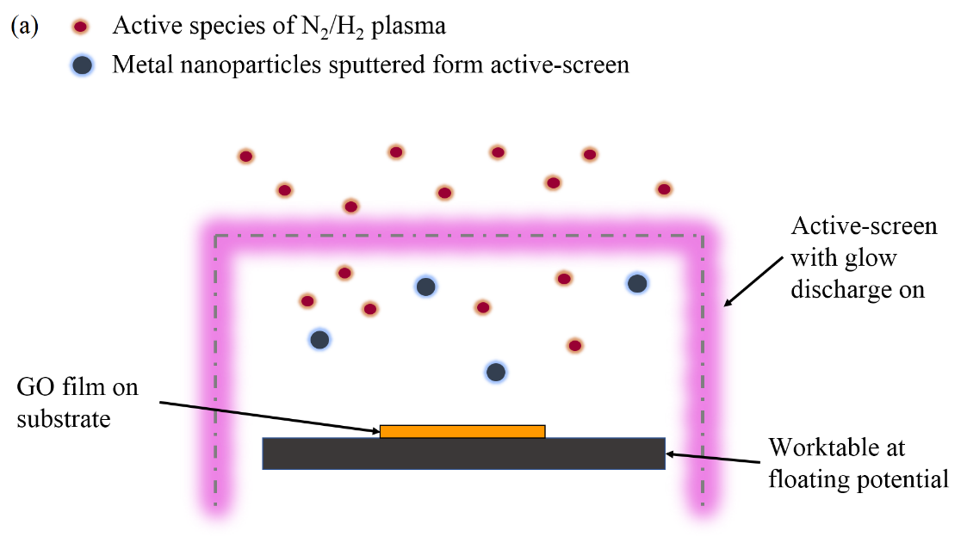

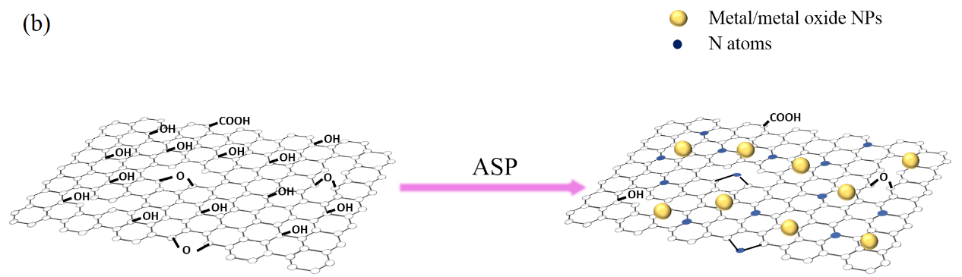
Fig. 12 Schematic illustration of (a) ASP treatment process, and (b) GO before and after ASP treatment
  - Potential for improved super-capacitive performance
The enhancement of super-capacitive performance can be attributed to two reasons. The first one is the reduction and nitrogen doping of GO. The elimination of oxygen functional groups along with the incorporation of nitrogen atoms in the graphene structure can improve the electrical conductivity, which is favored for a supercapacitor electrode [60]. This has been confirmed by the decrease of sheet resistance, and the Nyquist plot as well as the IR drop in the GCD results. Different configurations of nitrogen doping play different roles in tailoring properties of graphene [61]. Graphitic N is believed to play the key role in improving the electrical conductivity, acting as electron donor and facilitating the charge transfer during the charge/discharge process [16]. This is supported by the predominance of graphitic N as revealed by the XPS results. On the other hand, the pyridinic N next to vacancies exhibits the opposite behavior to graphitic N in tuning the electronic density of states and shifting Dirac cone, thus counterbalance the effect of graphitic N [41]. The absence of pyridinic N in this case, as shown in XPS results, enables the graphitic N to fully function for the electrical improvement. Meanwhile, pyrrolic N can also increase the pseudo-capacitance, for their faster and reversible redox reaction as active sites on graphene [62]. In addition, nitrogen functional groups are also believed to increase the wettability of GO in aqueous solutions for their polarity, so that the ion diffusion in the interface between the electrode and electrolyte can be facilitated [63].
The decoration of metal/metal oxides is the other reason attributing to the improvement of super-capacitive performance. These metal NPs deposited on the surface of GO increase the SSA of GO for more ion adsorption and larger charge storage [7]. Furthermore, Synthesizing graphene-transition metal oxides composites is a common strategy to increase the pseudocapacitive performance of electrodes made of graphene-based material [64].The iron and manganese NPs deposited on the GO surface in ASP treatment were exposed to the atmosphere and tend to be oxidized in air after the treatment, which could also attribute to the improvement of super-capacitive performance [65]. In addition, the aggregation and layer stacking prohibit the diffusion of electrolyte into graphene electrode, having a negative effect on the performance of supercapacitors. Plasma treatment has been demonstrated to avoid the aggregation that easily occurs in wet chemical methods, assisting the NPs deposited on the graphene layers evenly [66]. The combination of gas-phase plasma method and NPs deposition ensures the excellence of the electrochemical performance of ASP-GO.
- Summary and conclusion
An advanced active-screen plasma (ASP) multi-functional technique combining the reduction, nitrogen doping, and metal/metal oxide NPs decoration of GO in one-step treatment has been developed from this study. The new ASP treatment is more effective in reducing GO to a higher degree, as compared to conventional thermal annealing treatment at the same temperature for the same treatment time. XPS results release that graphitic N is the main doping configuration with a small proportion of pyrrolic N, but without pyridinic N. The ASP multi-functionalized GO have shown significantly improved electrical properties and effectively enhanced super-capacitive performance, due to the reduction, nitrogen doping and metal/metal oxides NPs decoration.

Conflicts of interest or competing interests
The authors declare no conflicts of interest.

References
1. Poonam, Sharma K, Arora A, Tripathi SK (2019) Review of supercapacitors: Materials and devices. J Energy Storage 21:801–825. https://doi.org/10.1016/j.est.2019.01.010
2. Wang Y, Song Y, Xia Y (2016) Electrochemical capacitors: Mechanism, materials, systems, characterization and applications. Chem Soc Rev 45:5925–5950. https://doi.org/10.1039/c5cs00580a
3. Hou J, Cao C, Idrees F, Ma X (2015) Hierarchical porous nitrogen-doped carbon nanosheets derived from silk for ultrahigh-capacity battery anodes and supercapacitors. ACS Nano 9:2556–2564. https://doi.org/10.1021/nn506394r
4. Ke Q, Wang J (2016) Graphene-based materials for supercapacitor electrodes – A review. J. Mater. 2:37–54
5. Bonaccorso F, Colombo L, Yu G, et al (2015) Graphene, related two-dimensional crystals, and hybrid systems for energy conversion and storage. Science (80-. ). 347
6. Kumar NA, Baek JB (2015) Doped graphene supercapacitors. Nanotechnology 26:. https://doi.org/10.1088/0957-4484/26/49/492001
7. Li Z, Qi S, Liang Y, et al (2018) Plasma surface functionalization of carbon nanofibres with silver, palladium and platinum nanoparticles for cost-effective and high-performance supercapacitors. Micromachines 10:. https://doi.org/10.3390/mi10010002
8. Borenstein A, Hanna O, Attias R, et al (2017) Carbon-based composite materials for supercapacitor electrodes: A review. J. Mater. Chem. A 5:12653–12672
9. Singh G, Sutar DS, Divakar Botcha V, et al (2013) Study of simultaneous reduction and nitrogen doping of graphene oxide Langmuir-Blodgett monolayer sheets by ammonia plasma treatment. Nanotechnology 24:. https://doi.org/10.1088/0957-4484/24/35/355704
10. Hummers WS, Offeman RE (1958) Preparation of Graphitic Oxide. J Am Chem Soc 80:1339–1339. https://doi.org/10.1021/ja01539a017
11. Jiang F, Zhang J, Li N, et al (2019) Nitrogen-doped graphene prepared by thermal annealing of fluorinated graphene oxide as supercapacitor electrode. J Chem Technol Biotechnol 94:3530–3537. https://doi.org/10.1002/jctb.6147
12. Ramesh S, Karuppasamy K, Kim HS, et al (2018) Hierarchical Flowerlike 3D nanostructure of Co3O4@MnO2/N-doped Graphene oxide (NGO) hybrid composite for a high-performance supercapacitor. Sci Rep 8:1–11. https://doi.org/10.1038/s41598-018-34905-7
13. Liu J, Du P, Wang Q, et al (2019) Electrochimica Acta Mild synthesis of holey N-doped reduced graphene oxide and its double-edged effects in polyaniline hybrids for supercapacitor application. Electrochim Acta 305:175–186. https://doi.org/10.1016/j.electacta.2019.03.049
14. Zhang H, Kuila T, Kim NH, et al (2014) Simultaneous reduction, exfoliation, and nitrogen doping of graphene oxide via a hydrothermal reaction for energy storage electrode materials. Carbon N Y 69:66–78. https://doi.org/10.1016/j.carbon.2013.11.059
15. Shazali SS, Amiri A, Mohd Zubir MN, et al (2018) Facile hydrothermal method for synthesizing nitrogen-doped graphene nanoplatelets using aqueous ammonia: Dispersion, stability in solvents and thermophysical perfomances (Materials Research Express DOI: 10.1088/2053-1591/aab527). Mater Res Express 5:. https://doi.org/10.1088/2053-1591/aac59f
16. Rybin M, Pereyaslavtsev A, Vasilieva T, et al (2016) Efficient nitrogen doping of graphene by plasma treatment. Carbon N Y 96:196–202. https://doi.org/10.1016/j.carbon.2015.09.056
17. Bertóti I, Mohai M, László K (2015) Surface modification of graphene and graphite by nitrogen plasma: Determination of chemical state alterations and assignments by quantitative X-ray photoelectron spectroscopy. Carbon N. Y. 84:185–196
18. Duan L, Zhao L, Cong H, et al (2019) Plasma Treatment for Nitrogen-Doped 3D Graphene Framework by a Conductive Matrix with Sulfur for High-Performance Li – S Batteries. Small 15:1–8. https://doi.org/10.1002/smll.201804347
19. Li J, Chen C, Zhang R, Wang X (2015) Nanoscale zero-valent iron particles supported on reduced graphene oxides by using a plasma technique and their application for removal of heavy-metal ions. Chem. - An Asian J. 10:1410–1417
20. Wang Q, Song M, Chen C, et al (2012) Synthesis of graphene-based Pt nanoparticles by a one-step in situ plasma approach under mild conditions. Appl Phys Lett 101:. https://doi.org/10.1063/1.4737421
21. Dao VD, Jung SH, Kim JS, et al (2015) AuNP/graphene nanohybrid prepared by dry plasma reduction as a low-cost counter electrode material for dye-sensitized solar cells. Electrochim Acta 156:138–146. https://doi.org/10.1016/j.electacta.2014.12.109
22. Wei Y, Zuo X, Li X, et al (2014) Dry plasma synthesis of graphene oxide-Ag nanocomposites: A simple and green approach. Mater Res Bull 53:145–150. https://doi.org/10.1016/j.materresbull.2014.02.015
23. Liang Y, Li X, Semitekolos D, et al (2020) Enhanced properties of PAN-derived carbon fibres and resulting composites by active screen plasma surface functionalisation. Plasma Process Polym. https://doi.org/10.1002/ppap.201900252
24. Chen J, Shi X, Qi S, et al (2015) Reducing and multiple-element doping of graphene oxide using active screen plasma treatments. Carbon N Y 95:338–346. https://doi.org/10.1016/j.carbon.2015.08.046
25. Corujeira Gallo S, Charitidis C, Dong H (2017) Surface functionalization of carbon fibers with active screen plasma. J Vac Sci Technol A Vacuum, Surfaces, Film 35:021404. https://doi.org/10.1116/1.4974913
26. Corujeira Gallo S, Li X, Fütterer K, et al (2017) Carbon Nanofibers Functionalized with Active Screen Plasma-Deposited Metal Nanoparticles for Electrical Energy Storage Devices. ACS Appl Mater Interfaces 9:23195–23201. https://doi.org/10.1021/acsami.7b05567
27. Kumar R, Sharma AK, Bhatnagar M, et al (2013) Antireflection properties of graphene layers on planar and textured silicon surfaces. Nanotechnology 24:. https://doi.org/10.1088/0957-4484/24/16/165402
28. Saito R, Hofmann M, Dresselhaus G, et al (2011) Raman spectroscopy of graphene and carbon nanotubes. Adv Phys 60:413–550. https://doi.org/10.1080/00018732.2011.582251
29. Malard LM, Pimenta MA, Dresselhaus G, Dresselhaus MS (2009) Raman spectroscopy in graphene. Phys Rep 473:51–87. https://doi.org/10.1016/j.physrep.2009.02.003
30. Ferrari AC, Basko DM (2013) Raman spectroscopy as a versatile tool for studying the properties of graphene. Nat. Nanotechnol. 8:235–246
31. Hulman M (2014) Raman spectroscopy of graphene. Graphene Prop Prep Characterisation Devices 156–183. https://doi.org/10.1533/9780857099334.2.156
32. Pei S, Cheng HM (2012) The reduction of graphene oxide. Carbon N Y 50:3210–3228. https://doi.org/10.1016/j.carbon.2011.11.010
33. Ferrari AC (2007) Raman spectroscopy of graphene and graphite: Disorder, electron-phonon coupling, doping and nonadiabatic effects. Solid State Commun 143:47–57. https://doi.org/10.1016/j.ssc.2007.03.052
34. Ferrari AC, Rodil SE, Robertson J, et al (2003) Interpretation of infrared and Raman spectra of amorphous carbon nitrides. Phys Rev B - Condens Matter Mater Phys 67:1–20. https://doi.org/10.1103/PhysRevB.67.155306
35. Wang X, Lv L, Cheng Z, et al (2016) High-Density Monolith of N-Doped Holey Graphene for Ultrahigh Volumetric Capacity of Li-Ion Batteries. Adv Energy Mater 6:1–7. https://doi.org/10.1002/aenm.201502100
36. Tao H, Yan C, Robertson AW, et al (2017) N-Doping of graphene oxide at low temperature for the oxygen reduction reaction. Chem Commun 53:873–876. https://doi.org/10.1039/c6cc08776k
37. Wang Y, Yu F, Zhu M, et al (2018) N-Doping of plasma exfoliated graphene oxide: Via dielectric barrier discharge plasma treatment for the oxygen reduction reaction. J Mater Chem A 6:2011–2017. https://doi.org/10.1039/c7ta08607e
38. Kumar NA, Nolan H, McEvoy N, et al (2013) Plasma-assisted simultaneous reduction and nitrogen doping of graphene oxide nanosheets. J Mater Chem A 1:4431–4435. https://doi.org/10.1039/c3ta10337d
39. Jiang H, Liu L, Zhao K, et al (2020) Effect of pyridinic- and pyrrolic-nitrogen on electrochemical performance of Pd for formic acid electrooxidation. Electrochim Acta 337:135758. https://doi.org/10.1016/j.electacta.2020.135758
40. Cheng M, Yang R, Zhang L, et al (2012) Restoration of graphene from graphene oxide by defect repair. Carbon N Y 50:2581–2587. https://doi.org/10.1016/j.carbon.2012.02.016
41. Scardamaglia M, Struzzi C, Osella S, et al (2016) Tuning nitrogen species to control the charge carrier concentration in highly doped graphene. 2D Mater 3:. https://doi.org/10.1088/2053-1583/3/1/011001
42. Elessawy NA, El Nady J, Wazeer W, Kashyout AB (2019) Development of High-Performance Supercapacitor based on a Novel Controllable Green Synthesis for 3D Nitrogen Doped Graphene. Sci Rep 9:1–10. https://doi.org/10.1038/s41598-018-37369-x
43. Sahu V, Grover S, Tulachan B, et al (2015) Heavily nitrogen doped, graphene supercapacitor from silk cocoon. Electrochim Acta 160:244–253. https://doi.org/10.1016/j.electacta.2015.02.019
44. Saha D, Li Y, Bi Z, et al (2014) Studies on supercapacitor electrode material from activated lignin-derived mesoporous carbon. Langmuir 30:900–910. https://doi.org/10.1021/la404112m
45. Mei BA, Munteshari O, Lau J, et al (2018) Physical Interpretations of Nyquist Plots for EDLC Electrodes and Devices. J Phys Chem C 122:194–206. https://doi.org/10.1021/acs.jpcc.7b10582
46. Taberna PL, Simon P, Fauvarque JF (2003) Electrochemical Characteristics and Impedance Spectroscopy Studies of Carbon-Carbon Supercapacitors. J Electrochem Soc 150:A292. https://doi.org/10.1149/1.1543948
47. Kakaei K, Hamidi M, Kakaei N (2019) Simultaneous electro-synthesis of polyaniline graphene nanocomposite in dilute graphene oxide as dopant and aniline by electrochemical method and its high specific capacitance. Mater Res Express 6:. https://doi.org/10.1088/2053-1591/ab2312
48. Yang D, Velamakanni A, Bozoklu G, et al (2009) Chemical analysis of graphene oxide films after heat and chemical treatments by X-ray photoelectron and Micro-Raman spectroscopy. Carbon N Y 47:145–152. https://doi.org/10.1016/j.carbon.2008.09.045
49. Jung I, Dikin DA, Piner RD, Ruoff RS (2008) Tunable electrical conductivity of individual graphene oxide sheets reduced at “Low” temperatures. Nano Lett 8:4283–4287. https://doi.org/10.1021/nl8019938
50. Acik M, Lee G, Mattevi C, et al (2011) The role of oxygen during thermal reduction of graphene oxide studied by infrared absorption spectroscopy. J Phys Chem C 115:19761–19781. https://doi.org/10.1021/jp2052618
51. Krishnamoorthy K, Ananth A, Mok YS, Kim SJ (2014) Plasma Assisted Synthesis of Graphene Nanosheets and Their Supercapacitor Applications. Sci Adv Mater 6:349–353. https://doi.org/10.1166/sam.2014.1722
52. Singh G, Botcha VD, Sutar DS, et al (2014) Near room temperature reduction of graphene oxide Langmuir-Blodgett monolayers by hydrogen plasma. Phys Chem Chem Phys 16:11708–11718. https://doi.org/10.1039/c4cp00875h
53. Anthony B (1989) In situ cleaning of silicon substrate surfaces by remote plasma-excited hydrogen. J Vac Sci Technol B Microelectron Nanom Struct 7:621. https://doi.org/10.1116/1.584805
54. Chen L, Zhang X, Huang L, Lei L (2010) Post-plasma catalysis for methane partial oxidation to methanol: Role of the copper-promoted iron oxide catalyst. Chem Eng Technol 33:2073–2081. https://doi.org/10.1002/ceat.201000092
55. Borisyuk Y V., Oreshnikova NM, Mozgrin D V., et al (2016) Pulse-periodic abnormal glow discharge in nitrogen, argon, hydrogen and their mixtures. J Phys Conf Ser 747:. https://doi.org/10.1088/1742-6596/747/1/012019
56. Dias A, Bundaleski N, Tatarova E, et al (2016) Production of N-graphene by microwave N2-Ar plasma. J Phys D Appl Phys 49:. https://doi.org/10.1088/0022-3727/49/5/055307
57. Suzuki A, Asahina S (2014) Dependence of composition of stable molecules in N2-H2 plasmas on nitrogen gas flow rate ratio measured using a quartz sensor. Jpn J Appl Phys 53:. https://doi.org/10.7567/JJAP.53.11RC03
58. Mohai M, Bertóti I (2016) Modification of graphene-oxide surface in nitrogen and argon glow discharge plasma. Surf Interface Anal 48:461–464. https://doi.org/10.1002/sia.5929
59. Qin S, Xu Q (2017) Room temperature ferromagnetism in N2 plasma treated graphene oxide. J Alloys Compd 692:332–338. https://doi.org/10.1016/j.jallcom.2016.09.055
60. Kim MJ, Jeong Y, Sohn SH, et al (2013) Fast and low-temperature reduction of graphene oxide films using ammonia plasma. AIP Adv 3:1–7. https://doi.org/10.1063/1.4789545
61. Lu Y, Huang Y, Zhang M, Chen Y (2014) Nitrogen-doped graphene materials for supercapacitor applications. J. Nanosci. Nanotechnol. 14:1134–1144
62. Wang Y, Zhang K, Wang R, et al (2019) Plasma jet printing for preparation of N-doped graphene electrode. J Mater Sci Mater Electron 8944–8954. https://doi.org/10.1007/s10854-019-01222-2
63. Han J, Xu G, Dou H, MacFarlane DR (2015) Porous nitrogen-doped carbon microspheres derived from microporous polymeric organic frameworks for high performance electric double-layer capacitors. Chem - A Eur J 21:2310–2314. https://doi.org/10.1002/chem.201404975
64. Jana A, Scheer E, Polarz S (2017) Synthesis of graphene-transition metal oxide hybrid nanoparticles and their application in various fields. Beilstein J Nanotechnol 8:688–714. https://doi.org/10.3762/bjnano.8.74
65. Yan J, Fan Z, Wei T, et al (2010) Fast and reversible surface redox reaction of graphene-MnO2 composites as supercapacitor electrodes. Carbon N Y 48:3825–3833. https://doi.org/10.1016/j.carbon.2010.06.047
66. Miao Y, Ma Y, Wang Q (2019) Plasma-Assisted Simultaneous Reduction and Nitrogen/Sulfur Codoping of Graphene Oxide for High-Performance Supercapacitors. ACS Sustain Chem Eng 7:7597–7608. https://doi.org/10.1021/acssuschemeng.8b05838

